# 

**Table of Contents**

**1. Executive Summary** **6**

**2. Data Overview** **7**

**3. Data Integration** **8**

3.1. Utilized Code 8

3.1.1. get_all_files_from_directories 8

3.1.2. merge_files 9

3.2. Integrated Dataset Shape 10

**4. Data Pre-process** **11**

4.1. Data Cleaning 11

4.1.1. Dropping Percentage Columns 11

4.1.1.1. Code 11

4.1.2. Add & Sort By Date 11

4.1.2.1. Code 12

4.1.3. Shifting Columns 12

4.1.3.1. Code 12

4.1.4. Rename Columns 12

4.1.4.1. Code 13

4.1.5. Remove Special Characters and Convert to Integer 13

4.1.5.1. Code 13

4.1.6. Rename Month Values 14

4.1.6.1. Code 14

4.1.7. Missing Data 14

4.1.7.1. Code 15

4.1.8. Label Region Based on County 15

4.1.8.1. Code 16

4.1.9. Shift Last Column to 5th Index 17

4.1.9.1. Code 17

4.1.10. Rename Conviction Columns 17

4.1.10.1. Code 18

4.2. Dataset Post Cleaning 18

4.2.1. Glimpse 18

4.2.2. Visualizing Missing 19

4.2.3. Visualizing Data Types 20

4.3. Dataset Split 20

4.3.1. Crime Dataset Glimpse 21

4.3.2. Unsuccessful Crime Dataset Glimpse 21

4.4. Code 21

**5. Descriptive Analytics** **23**

5.1. Attributes Analysis 23

5.1.1. Crimes Dataset 23

5.1.1.1. County 23

5.1.1.2. Year 23

5.1.1.3. Month 23

5.1.1.4. Yearmon 23

5.1.1.5. Region 23

5.1.1.6. Homicide 24

5.1.1.7. Offences_against_the_person 24

5.1.1.8. Sexual_offences 24

5.1.1.9. Burglary 24

5.1.1.10. Robbery 24

5.1.1.11. Theft_and_handling 24

5.1.1.12. Fraud_and_forgery 25

5.1.1.13. Criminal_damage 25

5.1.1.14. Drugs_offences 25

5.1.1.15. Public_order_offences 25

5.1.1.16. All_other_offences__excluding_motoring_ 25

5.1.1.17. Motoring_offences 25

5.1.2. Unsuccessful Crimes Dataset 26

5.1.2.1. County 26

5.1.2.2. Year 26

5.1.2.3. Month 26

5.1.2.4. Yearmon 26

5.1.2.5. Region 26

5.1.2.6. Homicide_us 26

5.1.2.7. Offences_against_the_person_us 27

5.1.2.8. Sexual_offences_us 27

5.1.2.9. Burglary_us 27

5.1.2.10. Robbery_us 27

5.1.2.11. Theft_and_handling_us 27

5.1.2.12. Fraud_and_forgery_us 27

5.1.2.13. Criminal_damage_us 28

5.1.2.14. Drugs_offences_us 28

5.1.2.15. Public_order_offences_us 28

5.1.2.16. All_other_offences__excluding_motoring__us 28

5.1.2.17. Motoring_offences_us 28

5.1.2.18. Admin_finalised_us 28

5.2. Analysis dependent on Regions 29

5.2.1. Region & All Types 29

5.2.1.1. Crimes 29

5.2.1.2. Unsuccessful Crimes 30

5.2.1.3. Code 30

5.2.2. Region & Sum of All 31

5.2.2.1. Crimes 31

5.2.2.2. Unsuccessful Crimes 31

5.2.2.3. Code 31

5.3. Analysis dependent on Years & Months 32

5.3.1. 2014 32

5.3.1.1. Crimes 32

5.3.1.2. Unsuccessful Crimes 33

5.3.2. 2015 34

5.3.2.1. Crimes 34

5.3.2.2. Unsuccessful Crimes 35

5.3.3. 2016 36

5.3.3.1. Crimes 36

5.3.3.2. Unsuccessful Crimes 37

5.3.4. 2017 38

5.3.4.1. Crimes 38

5.3.4.2. Unsuccessful Crimes 39

5.3.5. 2018 40

5.3.5.1. Crimes 40

5.3.5.2. Unsuccessful Crimes 41

5.3.6. Code 41

5.3.6.1. group_by_year_month 41

5.3.6.2. plot_graph 42

5.4. Analysis between Crime Types 43

5.4.1. Correlation 43

5.4.1.1. Crimes 43

5.4.1.2. Unsuccessful Crimes 44

5.4.1.3. Code 44

5.4.2. Covariance 46

5.4.2.1. Crimes 46

5.4.2.2. Unsuccessful Crimes 47

5.4.2.3. Code 47

5.5. Trend Analysis for Successful & Unsuccessful Crimes 49

5.5.1. Visualization 49

5.5.2. Code 49

**6. Predictive Analytics** **51**

6.1. Regression 51

6.1.1. Linear Regression 51

6.1.2. Multiple Regression 51

6.2. Clustering 51

6.2.1. KMeans 51

6.2.2. Hierarchical Clustering 51

6.3. Classification 51

6.3.1. SVM 51

6.3.2. Random Forest 51

**7. Prescriptive Analytics** **52**

7.1. Time Series Analytics 52

7.1.1. Crime 52

7.1.2. Un successful Crimes 52

**8. References** **53**

# 

# 1. Executive Summary

The data utilized to construct this analysis was derived from an uneven array of months; while those appended to the various years involved do not feature in their archive, they have nevertheless been taken into consideration.

In this analytics report, data exportation and integration were performed. Subsequently, an intensive cleaning of the desired data structure and methodology for performing a descriptive analysis, predictive analytics and prescriptive with hypothesis testing at each stage of analysis.

# 2. Data Overview

The dataset utilized for this report is the Crown Prosecution Service Case Outcomes by Principal Offense Category (POC) obtained from data.gov.uk website. The CPS outcomes are categorized into convictions and unsuccessful verdicts, with data spanning from 2014 to 2018 collected on a monthly basis in forty-two (42) counties throughout England where applicable.

The convictions comprise of guilty pleas, trials resulting in convictions and verdicts rendered against respondents who have not appeared in court. An incomplete outcome encompasses all other categories, equally comprising discontinuances and withdrawals; discharged committals; dismissals or acquittals; as well as administrative finalizations.

The offenses recorded comprise homicide, violations against the person such as sexual assault, burglary, robbery and theft; in addition to handling fraud or forgery along with criminal damage committed to public places and automobiles. All other offenses except motoring-related offenses are included within this category.

# 3. Data Integration

The dataset was scattered in the shape of directories for each year whereas each directory contained all possible months data for the parent directory representing the year. In response to the dataset shape, the chosen strategy was to first write a generic function that reads all possible files within the directories and create a hashmap. Afterwards, another function that reads the hashmap and merges all the files into a singular dataframe and within the process it creates columns for year and month extracted from the directory name and the file name respectively.

## 3.1. Utilized Code

The sections below contain each operation's code and description respectively.

### **3.1.1. get_all_files_from_directories**

| get_all_files_from_directories <- function () {  files <- hash()   files["2014"] <- list.files("dataset/2014", pattern=".csv")  files["2015"] <- list.files("dataset/2015", pattern=".csv")  files["2016"] <- list.files("dataset/2016", pattern=".csv")  files["2017"] <- list.files("dataset/2017", pattern=".csv")  files["2018"] <- list.files("dataset/2018", pattern=".csv")    return(files) } |
| --- |

The above R programming language code creates a function called get_all_files_from_directories which is used to store a list of files from different directories. It calls the list.files() function, which is used to list all the files in a directory. The pattern argument is used to specify the type of files that are to be listed. In this case, it is set to ".csv" which indicates that only files with the ".csv" extension should be listed. It then stores each of the resulting lists into a hash called 'files' and finally returns this hash.

### 3.1.2. merge_files

| merge_files <- function(hash) {  year <- names(hash)   combined_df <- do.call(rbind, lapply(year, function(y) {  do.call(rbind, lapply(hash[[y]], function(f) {  f_name <- paste("dataset/", y, "/", f, sep="")  df <- read.csv(f_name, stringsAsFactors = FALSE)  df$year <- y  df$month <- tolower(gsub(".csv", "", as.list(strsplit(f, "_")[[1]])[4]))  df  }))  }))  return(combined_df) } |
| --- |

The above code is used to merge multiple files into one. The function takes a hash as an argument, which contains the names of the years as keys and the names of the files as values. The function then uses the lapply() function to loop through the years and the files, and the do.call() function to combine the data frames. The read.csv() function is used to read the files, and the gsub() and strsplit() functions are used to extract the month from the file name. Finally, the year and month are added to the data frame and the combined data frame is returned.

## 3.2. Integrated Dataset Shape

After the integration was conducted, the dataset took the following structure as shared below.

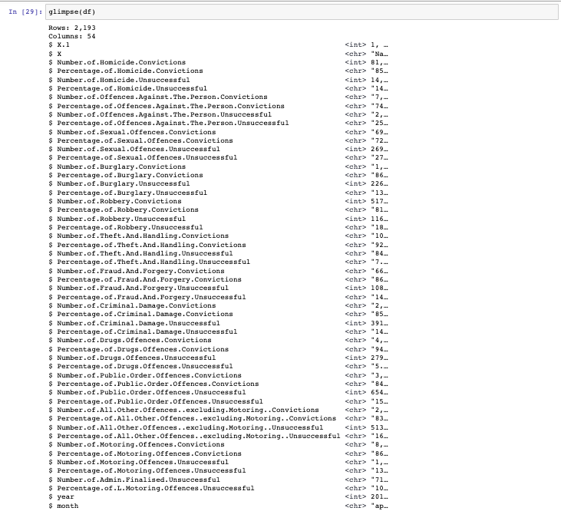

# 4. Data Pre-process

In order to carry out all data analytics with accurate results as well as to enable all the statistical algorithm’s smooth working, a series of data cleaning steps are performed to make sure the data is converted into highest quality. We would first look at each cleansing step one by one with reasoning and impact. Along with that, we would explore the code utilized to execute each cleaning operation.

## 4.1. Data Cleaning

The sections below contain each operation performed with reasoning and impact.

### 4.1.1. Dropping Percentage Columns

#### **4.1.1.1. Code**

| drop_percentage_columns <- function(dataframe) {  col_names <- colnames(dataframe)  to_drop <- grep("Percentage", col_names, value = TRUE)  dataframe <- dataframe[, !(col_names %in% to_drop)]  return(dataframe) } |
| --- |

The above code is a function written and it takes a dataframe as an argument. The first line of the function stores the column names of the dataframe in a variable called "col_names". The second line of the code uses the "grep" function to search for any column names that contain the word "Percentage" and stores the results in a variable called "to_drop". The third line of the code uses the "%in%" operator to subset the dataframe and remove any columns that are stored in the "to_drop" variable. Finally, the fourth line of the code returns the modified dataframe.

### 4.1.2. Add & Sort By Date

#### **4.1.2.1. Code**

| sort_by_yearmon <- function(dataframe){  dataframe$yearmon <- as.Date(paste(dataframe$year, dataframe$month, "01", sep = "-"), "%Y-%b-%d")  dataframe <- dataframe[order(dataframe$yearmon),]  return(dataframe) } |
| --- |

The above code is a function that sorts a dataframe by year and month. The function takes a dataframe as an argument and creates a new column called "yearmon" which is a date format of the year and month. The function then orders the dataframe by the newly created "yearmon" column and returns the sorted dataframe.

### 4.1.3. Shifting Columns

#### **4.1.3.1. Code**

| shift_columns <- function(dataframe){  cols <- colnames(dataframe)  cols <- c(cols[1], cols[(length(cols)-2):length(cols)], cols[2:(length(cols)-3)])  dataframe[, cols] } |
| --- |

The above code is a function that takes a dataframe as an argument. The function first creates a vector of the column names of the dataframe. It then reorders the vector by shifting the last two columns to the beginning of the vector and the second to last three columns to the end of the vector. Finally, the function returns the dataframe with the columns reordered according to the new vector.

### 4.1.4. Rename Columns

#### **4.1.4.1. Code**

| rename_columns <- function(dataframe){  colnames(dataframe) <- gsub("Number.of.", "", colnames(dataframe))  colnames(dataframe) <- gsub("\\.", "_", colnames(dataframe))  colnames(dataframe) <- tolower(colnames(dataframe))  return(dataframe) } |
| --- |

The above code is a function and it takes a dataframe as an argument. The function uses the gsub() function to remove the string "Number.of." from the column names of the dataframe, and then uses the gsub() function again to replace all periods in the column names with underscores. Finally, the function uses the tolower() function to convert all of the column names to lowercase. The function then returns the modified dataframe.

### 4.1.5. Remove Special Characters and Convert to Integer

#### **4.1.5.1. Code**

| remove_special_characters_and_convert_to_integer <- function(dataframe){  dataframe <- dataframe %>%   mutate_all(funs(gsub(",", "", .)))  dataframe[,5:ncol(dataframe)] <- sapply(dataframe[,5:ncol(dataframe)], as.integer)  return(dataframe) } |
| --- |

The above code is used to remove special characters and convert the dataframe to an integer. The dataframe is modified using the mutate_all function, which replaces all commas with an empty string. The fifth to last column of the dataframe is then converted to an integer using the sapply function. Finally, the modified dataframe is returned.

### 4.1.6. Rename Month Values



#### **4.1.6.1. Code**

| convert_months <- function(df){  df$month <- gsub("january", "jan", df$month)  df$month <- gsub("february", "feb", df$month)  df$month <- gsub( "march", "mar",df$month)  df$month <- gsub("april", "apr", df$month)  df$month <- gsub( "may", "may", df$month)  df$month <- gsub("june","jun", df$month)  df$month <- gsub( "july", "jul",df$month)  df$month <- gsub("august","aug", df$month)  df$month <- gsub("september", "sep", df$month)  df$month <- gsub( "october","oct", df$month)  df$month <- gsub("november", "nov", df$month)  df$month <- gsub("december","dec", df$month)  return(df) } |
| --- |

### 4.1.7. Missing Data

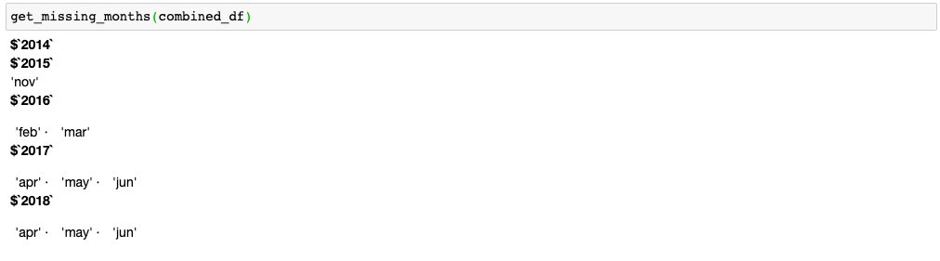

#### **4.1.7.1. Code**

| get_missing_months <- function(dataframe){  years <- unique(dataframe$year)  missing_months <- list()  for (year in years){  months <- unique(dataframe[dataframe$year == year,]$month)  all_months <- c("jan", "feb", "mar", "apr", "may", "jun", "jul", "aug", "sep", "oct", "nov", "dec")  diff <- setdiff(all_months, months)  missing_months[[year]] <- diff  }    return(missing_months) } |
| --- |

### 4.1.8. Label Region Based on County



| county_region_map <- list(  "National" = "All",  "Avon and Somerset" = "West",  "Bedfordshire" = "East",  "Cambridgeshire" = "East",  "Cheshire" = "North",  "Cleveland" = "North",  "Cumbria" = "North",  "Derbyshire" = "East",  "Devon and Cornwall" = "West",  "Dorset" = "West",  "Durham" = "North",  "Dyfed Powys" = "West",  "Essex" = "East",  "Gloucestershire" = "West",  "GreaterManchester" = "North",  "Gwent" = "West",  "Hampshire" = "South",  "Hertfordshire" = "East",  "Humberside" = "North",  "Kent" = "South",  "Lancashire" = "North",  "Leicestershire" = "East",  "Lincolnshire" = "East",  "Merseyside" = "North",  "Metropolitan and City" = "South",  "Norfolk" = "East",  "Northamptonshire" = "East",  "Northumbria" = "North",  "North Wales" = "North",  "North Yorkshire" = "North",  "Nottinghamshire" = "East",  "South Wales" = "West",  "South Yorkshire" = "North",  "Staffordshire" = "West",  "Suffolk" = "East",  "Surrey" = "South",  "Sussex" = "South",  "Thames Valley" = "South",  "Warwickshire" = "West",  "West Mercia" = "West",  "West Midlands" = "West",  "West Yorkshire" = "North",  "Wiltshire" = "West" ) |
| --- |

#### **4.1.8.1. Code**

| label_county_region <- function(df, county_region) {   region <- c()   for (i in 1:nrow(df)) {  county <- df$x[i]  region[i] <- county_region[[county]]  }    df$region <- region    return(df) } |
| --- |

### 4.1.9. Shift Last Column to 5th Index

#### **4.1.9.1. Code**

| move_last_column_to_5th <- function(dataframe) {  ncols <- ncol(dataframe)  region <- dataframe[, ncols]  dataframe <- dataframe[, -ncols]  dataframe <- cbind(dataframe[, 1:4], region, dataframe[, 5:(ncols-1)])  return(dataframe) } |
| --- |

### 4.1.10. Rename Conviction Columns

| rename_conviction_columns <- function(dataframe){  col_names <- colnames(dataframe)  for (i in 1:length(col_names)){  if (grepl("_convictions", col_names[i])){  names(dataframe)[names(dataframe) == col_names[i]] <- gsub("_convictions", "" ,col_names[i])  }else{  names(dataframe)[names(dataframe) == col_names[i]] <- gsub("_unsuccessful", "_us" ,col_names[i])  }  }  return(dataframe) } |
| --- |

#### **4.1.10.1. Code**

## **4.2.** Dataset Post Cleaning

### 4.2.1. Glimpse

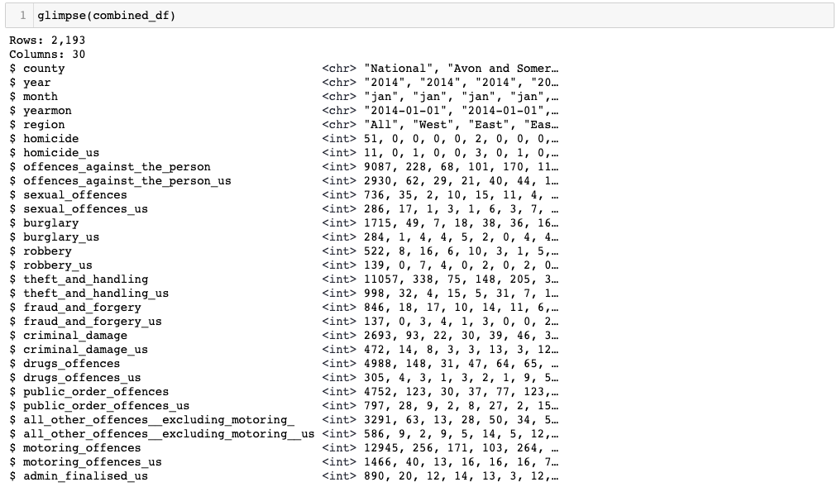

### 4.2.2. Visualizing Missing

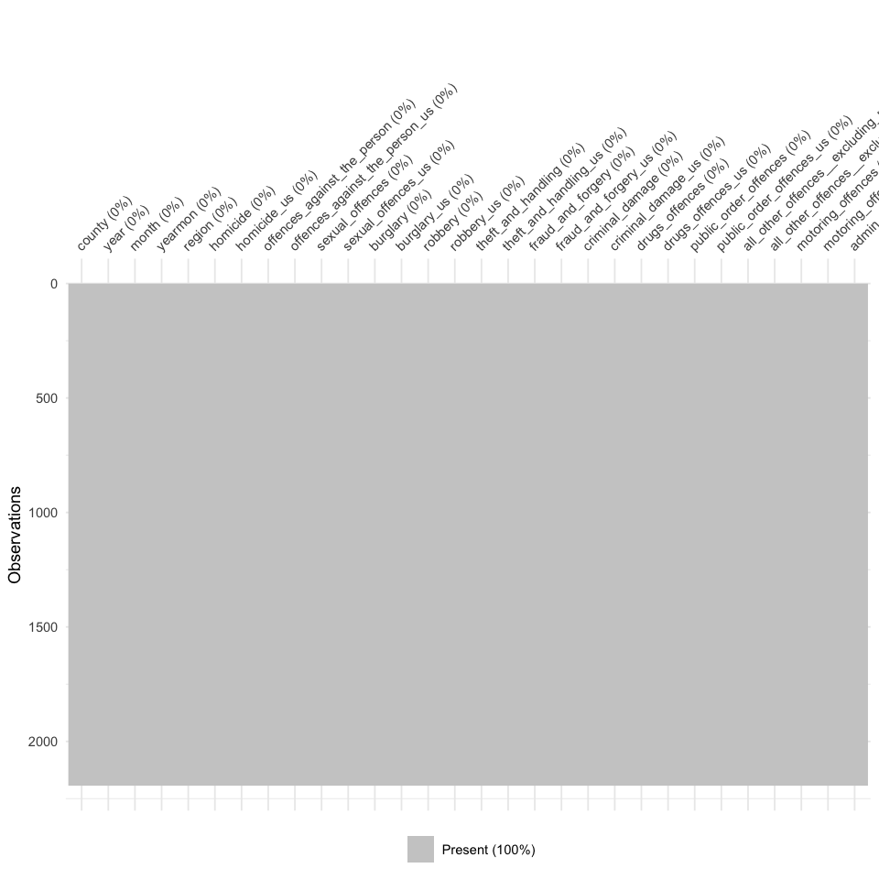

### 4.2.3. Visualizing Data Types

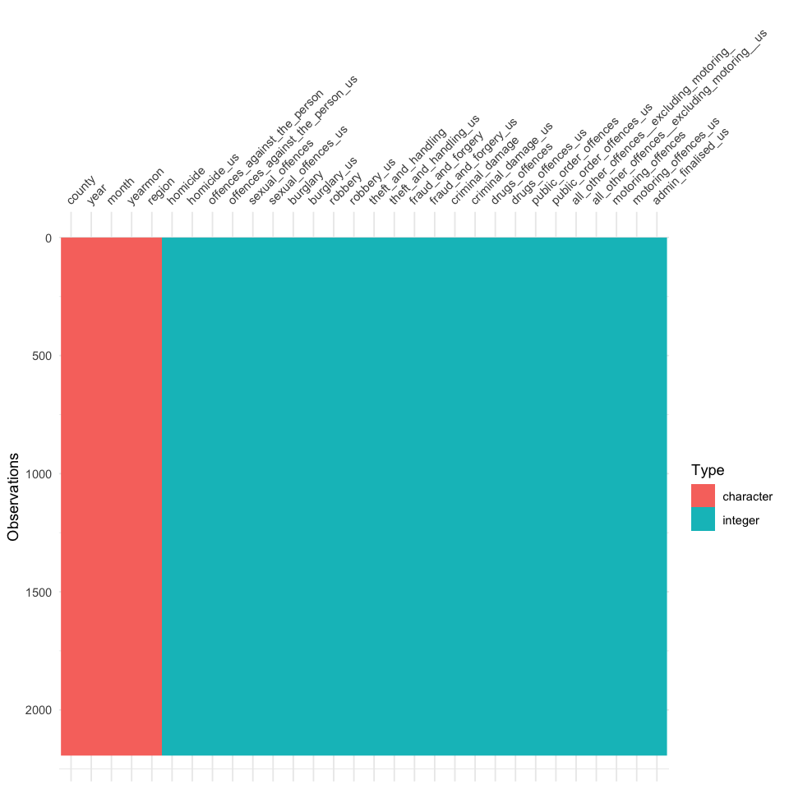

## 4.3. Dataset Split

### 4.3.1. Crime Dataset Glimpse

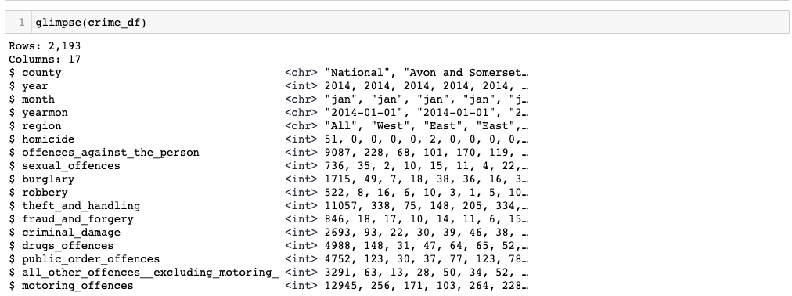

### 4.3.2. Unsuccessful Crime Dataset Glimpse

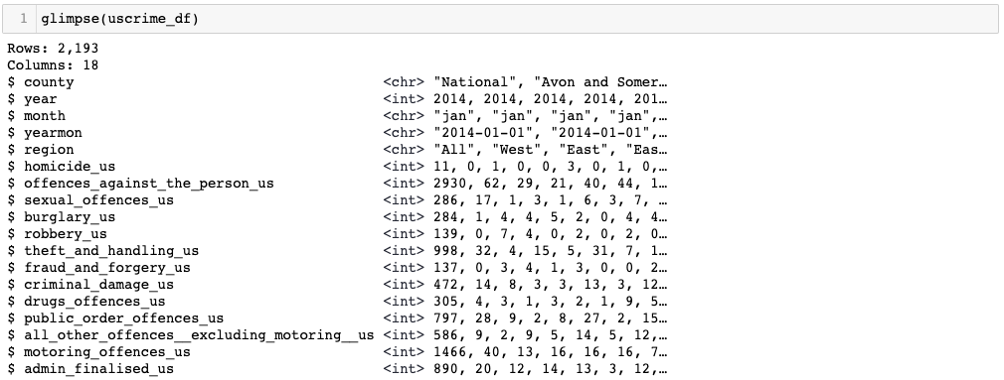

## 4.4. Code

| split_dataframe <- function(df){  crime_columns = !grepl("_us$", colnames(df))  unsuccesful_columns = grepl("_us$", colnames(df))  unsuccesful_columns[0:5] <- TRUE  df1 <- df[, crime_columns]  df2 <- df[, unsuccesful_columns]  return(list(df1, df2)) } |
| --- |

### 

# 5. Descriptive Analytics

Introduction here for descriptive analytics

## 5.1. Attributes Analysis

### 5.1.1. Crimes Dataset

#### 5.1.1.1. County

| Length Class Mode   2193 character character |
| --- |

#### 5.1.1.2. Year

| Min. 1st Qu. Median Mean 3rd Qu. Max.   2014 2015 2016 2016 2017 2018 |
| --- |

#### 5.1.1.3. Month

| Length Class Mode   2193 character character |
| --- |

#### 5.1.1.4. Yearmon

| Length Class Mode   2193 character character |
| --- |

#### 5.1.1.5. Region

| Length Class Mode   2193 character character |
| --- |

#### 5.1.1.6. Homicide

| Min. 1st Qu. Median Mean 3rd Qu. Max.   0.000 0.000 1.000 3.798 3.000 131.000 |
| --- |

#### 5.1.1.7. Offences_against_the_person

| Min. 1st Qu. Median Mean 3rd Qu. Max.   29.0 115.0 179.0 454.9 272.0 11741.0 |
| --- |

#### 

#### 5.1.1.8. Sexual_offences

| Min. 1st Qu. Median Mean 3rd Qu. Max.   0.00 8.00 15.00 43.78 29.00 1179.00 |
| --- |

#### 5.1.1.9. Burglary

| Min. 1st Qu. Median Mean 3rd Qu. Max.   1.00 14.00 23.00 60.09 38.00 1715.00 |
| --- |

#### 5.1.1.10. Robbery

| Min. 1st Qu. Median Mean 3rd Qu. Max.   0.00 2.00 5.00 19.33 10.00 650.00 |
| --- |

#### 5.1.1.11. Theft_and_handling

| Min. 1st Qu. Median Mean 3rd Qu. Max.   13.0 95.0 147.0 373.1 237.0 11057.0 |
| --- |

#### 5.1.1.12. Fraud_and_forgery

| Min. 1st Qu. Median Mean 3rd Qu. Max.   0.00 8.00 13.00 38.57 21.00 1075.00 |
| --- |

#### 5.1.1.13. Criminal_damage

| Min. 1st Qu. Median Mean 3rd Qu. Max.   3.00 25.00 40.00 95.82 59.00 2693.00 |
| --- |

#### 5.1.1.14. Drugs_offences

| Min. 1st Qu. Median Mean 3rd Qu. Max.   4.0 38.0 63.0 186.6 100.0 4988.0 |
| --- |

#### 5.1.1.15. Public_order_offences

| Min. 1st Qu. Median Mean 3rd Qu. Max.   2.0 39.0 63.0 162.4 100.0 4752.0 |
| --- |

#### 5.1.1.16. All_other_offences__excluding_motoring_

| Min. 1st Qu. Median Mean 3rd Qu. Max.   0.00 9.00 16.00 64.34 35.00 3291.00 |
| --- |

#### 5.1.1.17. Motoring_offences

| Min. 1st Qu. Median Mean 3rd Qu. Max.   1.0 95.0 143.0 365.5 216.0 12945.0 |
| --- |

### 5.1.2. Unsuccessful Crimes Dataset

#### 5.1.2.1. County

| Length Class Mode   2193 character character |
| --- |

#### 5.1.2.2. Year

| Min. 1st Qu. Median Mean 3rd Qu. Max.   2014 2015 2016 2016 2017 2018 |
| --- |

#### 5.1.2.3. Month

| Length Class Mode   2193 character character |
| --- |

#### 5.1.2.4. Yearmon

| Length Class Mode   2193 character character |
| --- |

#### 5.1.2.5. Region

| Length Class Mode   2193 character character |
| --- |

#### 5.1.2.6. Homicide_us

| Min. 1st Qu. Median Mean 3rd Qu. Max.   0.0000 0.0000 0.0000 0.9138 1.0000 35.0000 |
| --- |

#### 5.1.2.7. Offences_against_the_person_us

| Min. 1st Qu. Median Mean 3rd Qu. Max.   5.0 27.0 46.0 135.4 77.0 3568.0 |
| --- |

#### 5.1.2.8. Sexual_offences_us

| Min. 1st Qu. Median Mean 3rd Qu. Max.   0.00 1.00 4.00 16.19 11.00 489.00 |
| --- |

#### 5.1.2.9. Burglary_us

| Min. 1st Qu. Median Mean 3rd Qu. Max.   0.00 1.00 3.00 10.14 6.00 317.00 |
| --- |

#### 5.1.2.10. Robbery_us

| Min. 1st Qu. Median Mean 3rd Qu. Max.   0.00 0.00 1.00 5.16 3.00 188.00 |
| --- |

#### 5.1.2.11. Theft_and_handling_us

| Min. 1st Qu. Median Mean 3rd Qu. Max.   0.00 6.00 11.00 33.43 19.00 1025.00 |
| --- |

#### 5.1.2.12. Fraud_and_forgery_us

| Min. 1st Qu. Median Mean 3rd Qu. Max.   0.000 1.000 2.000 6.232 4.000 180.000 |
| --- |

#### 5.1.2.13. Criminal_damage_us

| Min. 1st Qu. Median Mean 3rd Qu. Max.   0.00 3.00 6.00 16.43 10.00 491.00 |
| --- |

#### 5.1.2.14. Drugs_offences_us

| Min. 1st Qu. Median Mean 3rd Qu. Max.   0.00 2.00 4.00 12.57 7.00 346.00 |
| --- |

#### 5.1.2.15. Public_order_offences_us

| Min. 1st Qu. Median Mean 3rd Qu. Max.   0.00 5.00 9.00 28.45 16.00 801.00 |
| --- |

#### 5.1.2.16. All_other_offences__excluding_motoring__us

| Min. 1st Qu. Median Mean 3rd Qu. Max.   0.00 1.00 3.00 11.91 7.00 603.00 |
| --- |

#### 5.1.2.17. Motoring_offences_us

| Min. 1st Qu. Median Mean 3rd Qu. Max.   0.00 11.00 20.00 60.95 34.00 1725.00 |
| --- |

#### 5.1.2.18. Admin_finalised_us

| Min. 1st Qu. Median Mean 3rd Qu. Max.   0.00 7.00 12.00 38.82 21.00 1051.00 |
| --- |

## 5.2. Analysis dependent on Regions

### 5.2.1. Region & All Types

#### 5.2.1.1. Crimes

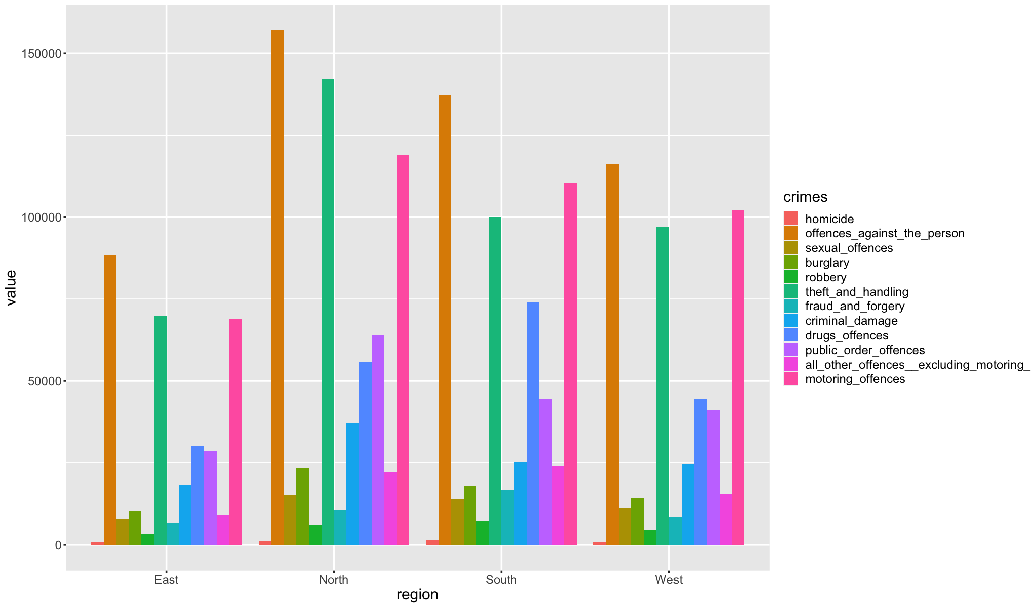

#### 5.2.1.2. Unsuccessful Crimes

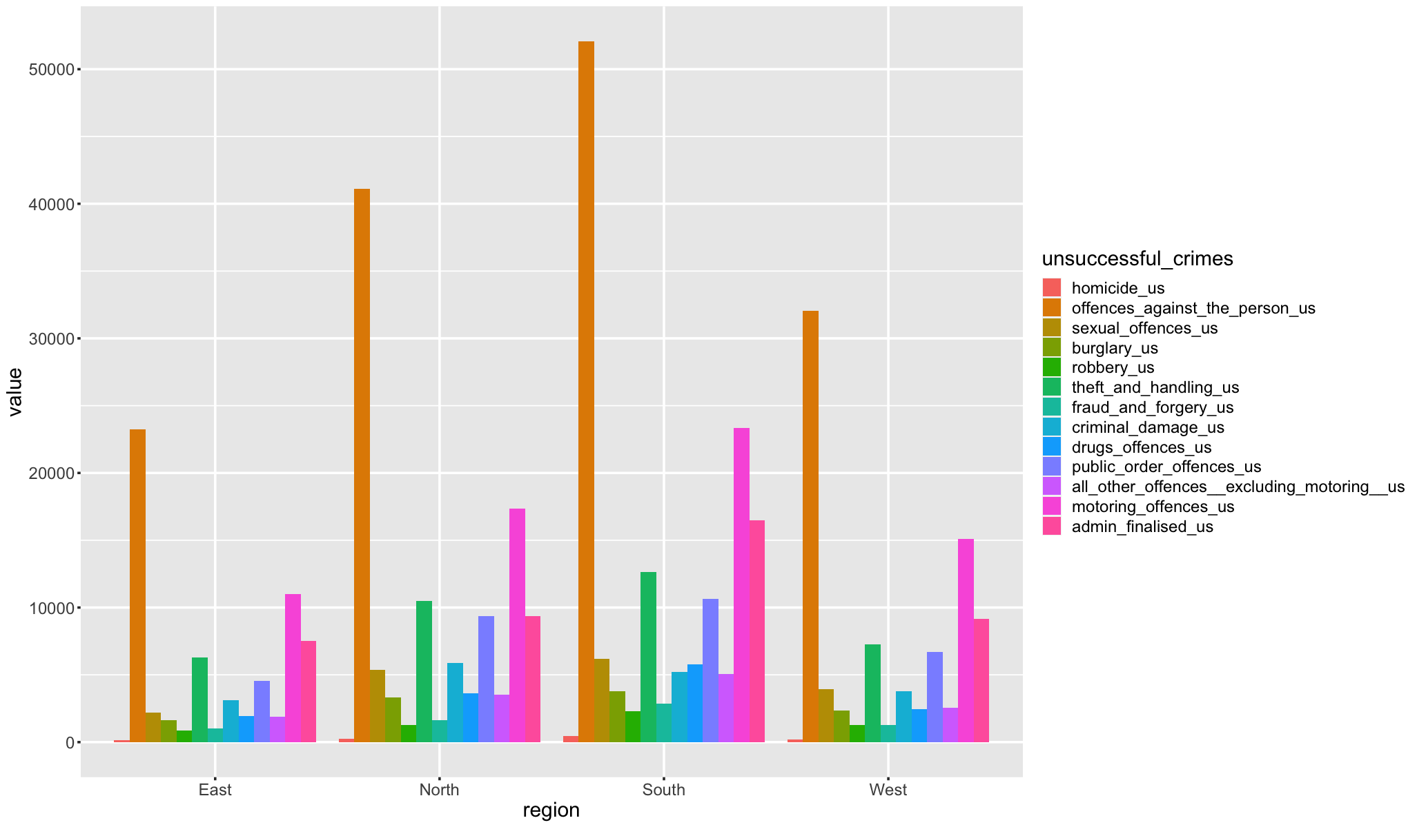

#### 5.2.1.3. Code

| group_by_region <- function(dataframe){  dataframe <- dataframe[,-c(1:4)]  dataframe <- dataframe[dataframe$region != "All",]  dataframe <- group_by(dataframe, region)  summarise_all(dataframe, funs(sum)) } |
| --- |

### 5.2.2. Region & Sum of All

#### 5.2.2.1. Crimes

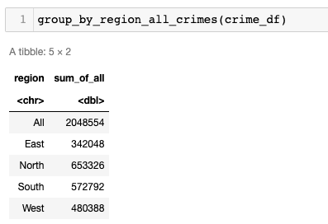

#### 5.2.2.2. Unsuccessful Crimes

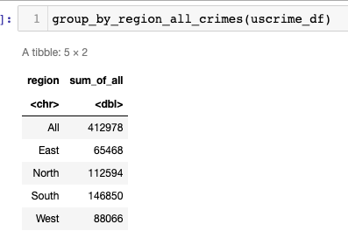

#### 5.2.2.3. Code

| group_by_region_all_crimes <- function(dataframe){  dataframe <- dataframe[,-c(1:4)]  dataframe$sum_of_all <- rowSums(dataframe[, sapply(dataframe, is.numeric)])  dataframe <- dataframe[, c("region", "sum_of_all")]  dataframe <- group_by(dataframe, region)  summarise_all(dataframe, funs(sum)) } |
| --- |

## 5.3. Analysis dependent on Years & Months

### 5.3.1. 2014

#### 5.3.1.1. Crimes

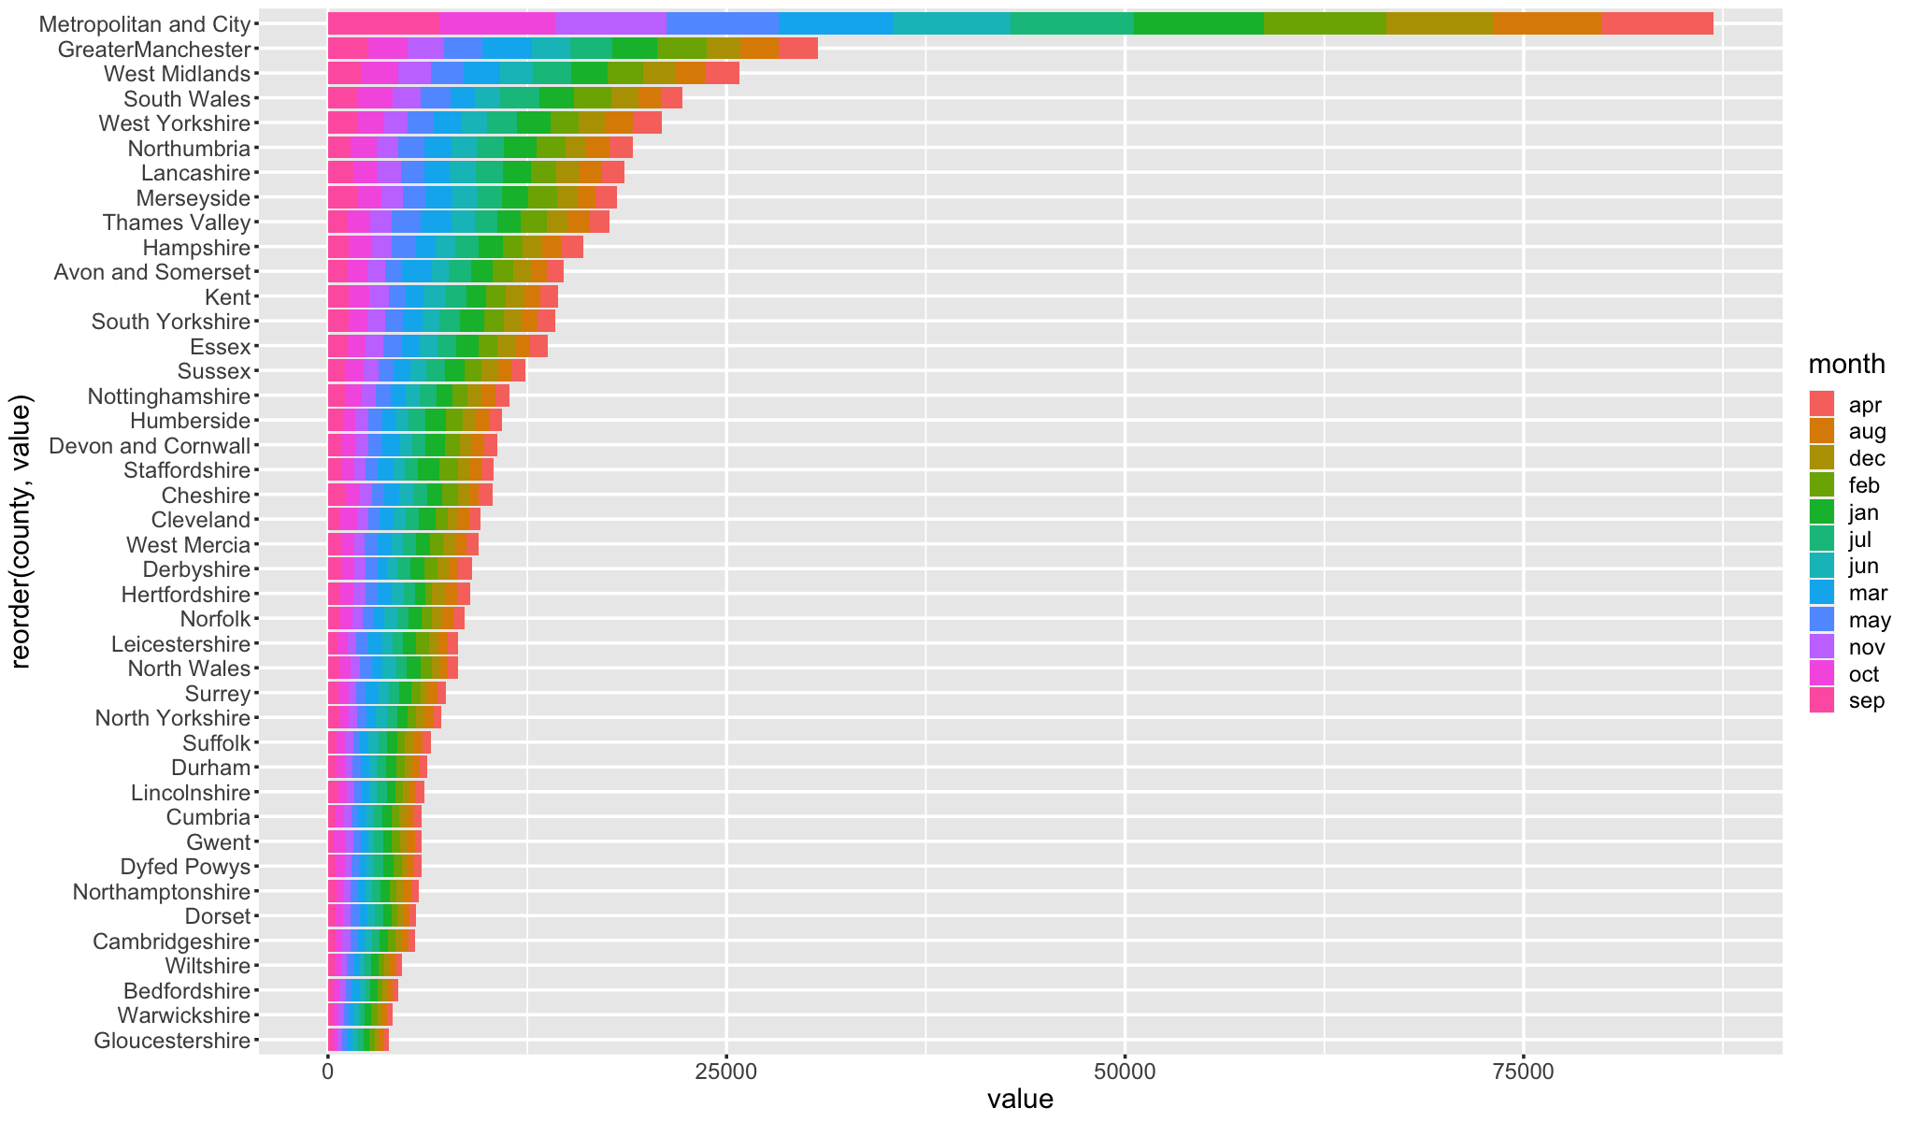

#### 5.3.1.2. Unsuccessful Crimes

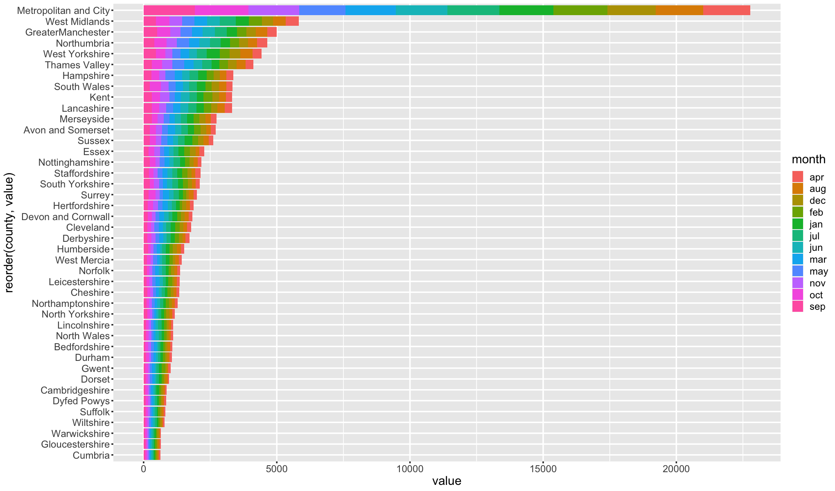

### 5.3.2. 2015

#### 5.3.2.1. Crimes

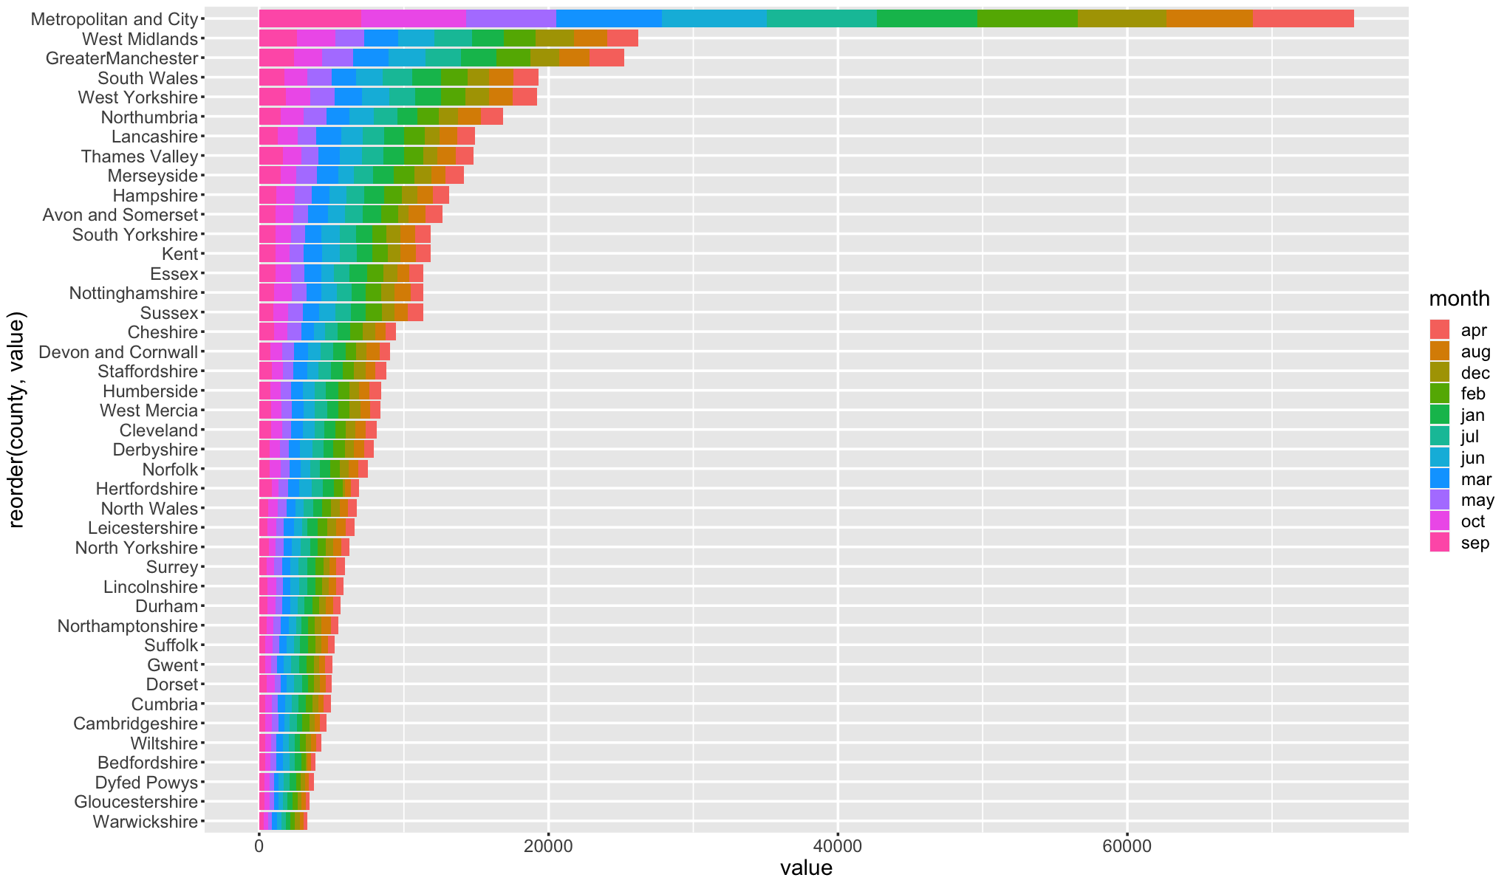

#### 5.3.2.2. Unsuccessful Crimes

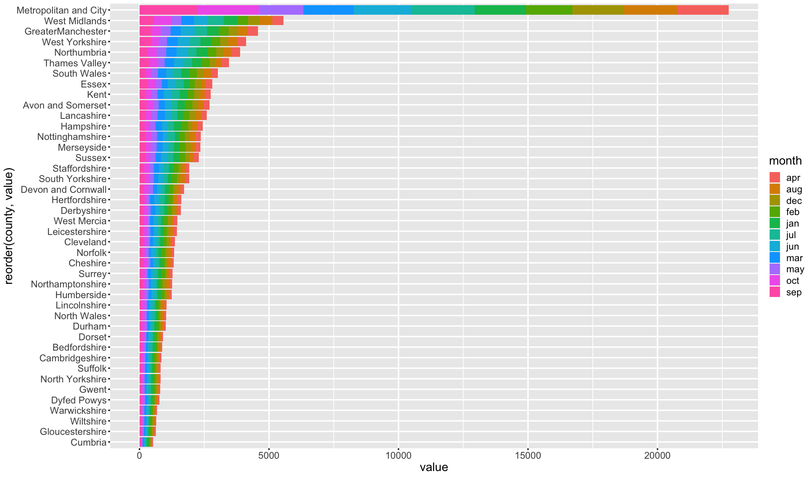

### 5.3.3. 2016

#### 5.3.3.1. Crimes

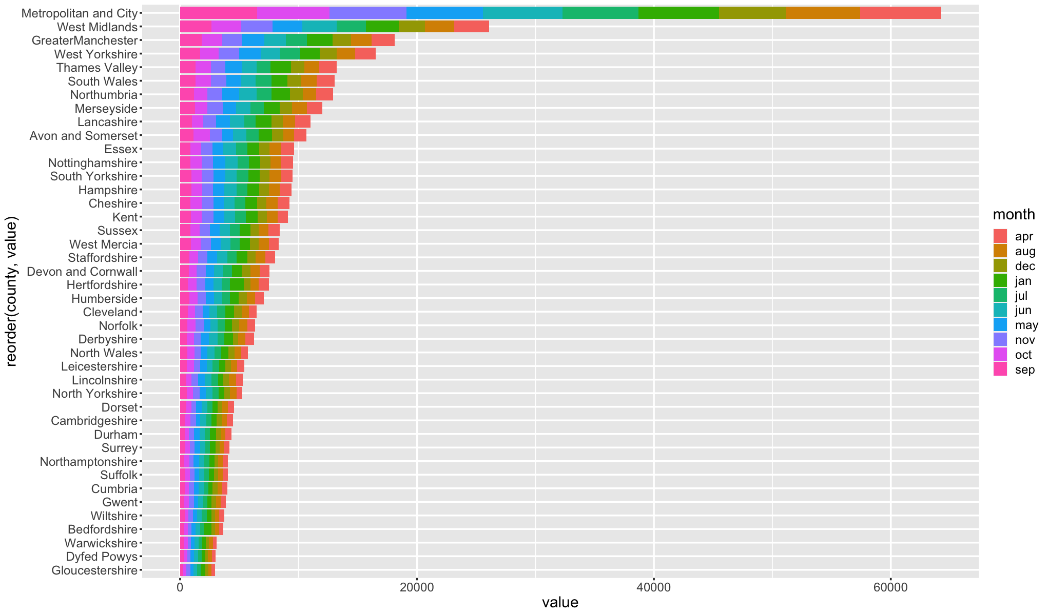

#### 5.3.3.2. Unsuccessful Crimes

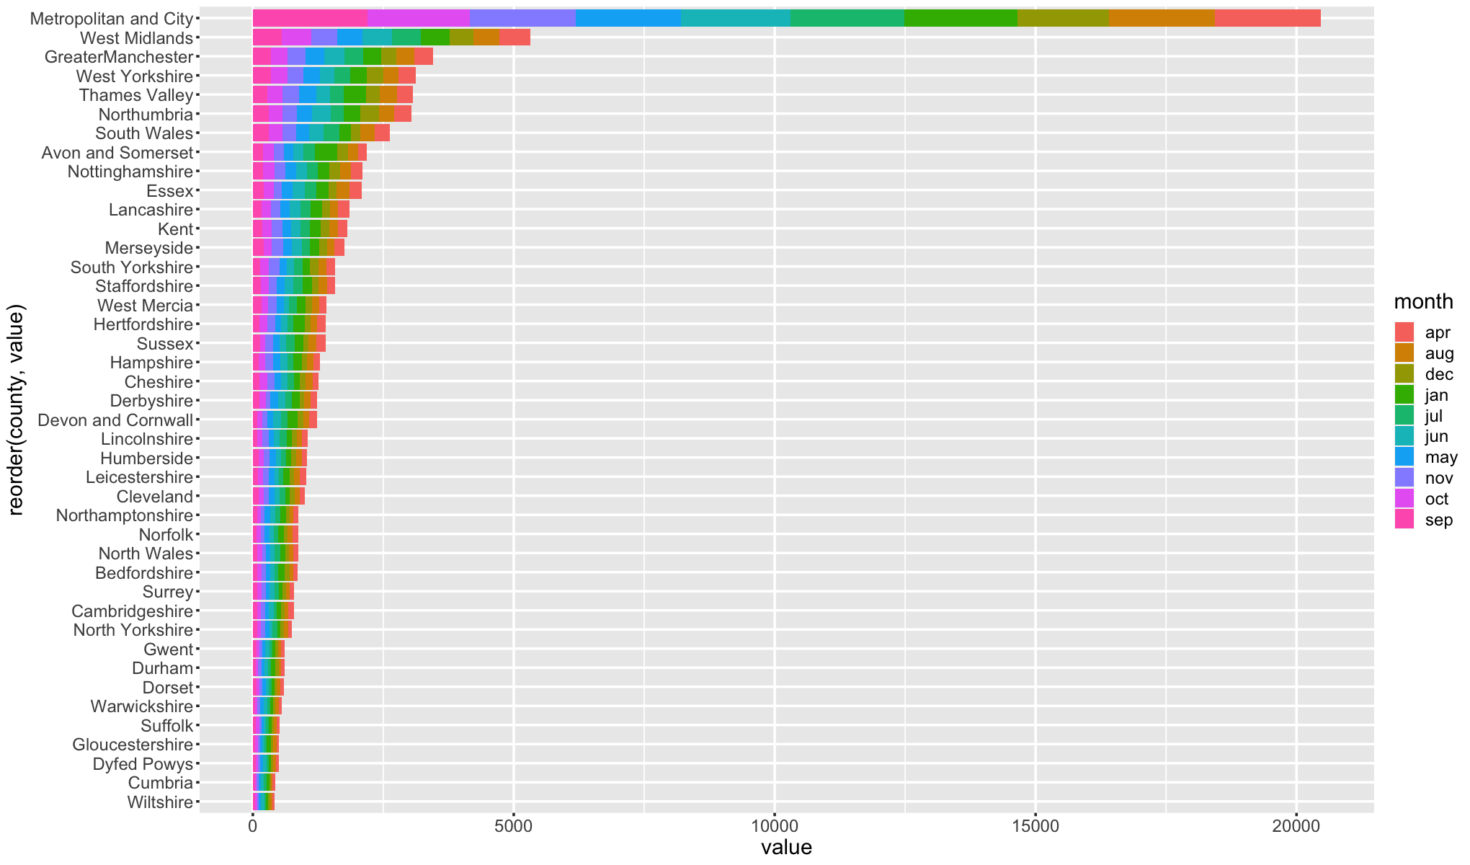

### 5.3.4. 2017

#### 5.3.4.1. Crimes

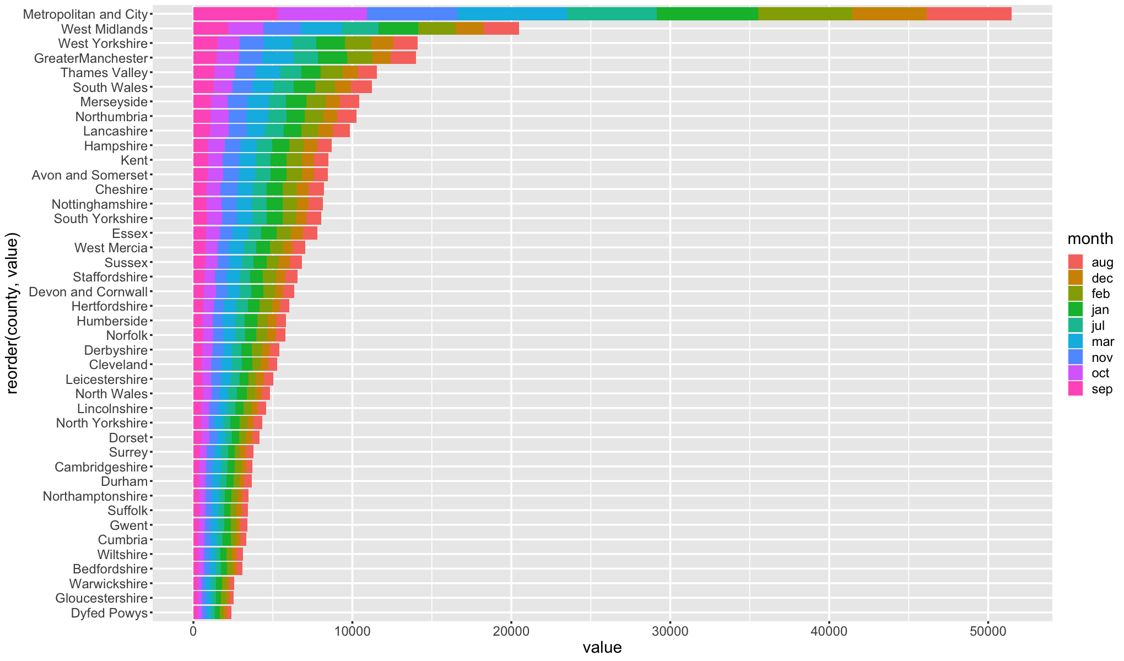

#### 5.3.4.2. Unsuccessful Crimes

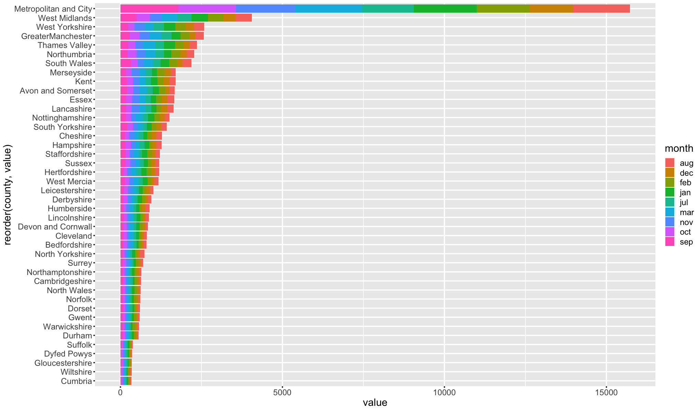

### 5.3.5. 2018

#### 5.3.5.1. Crimes

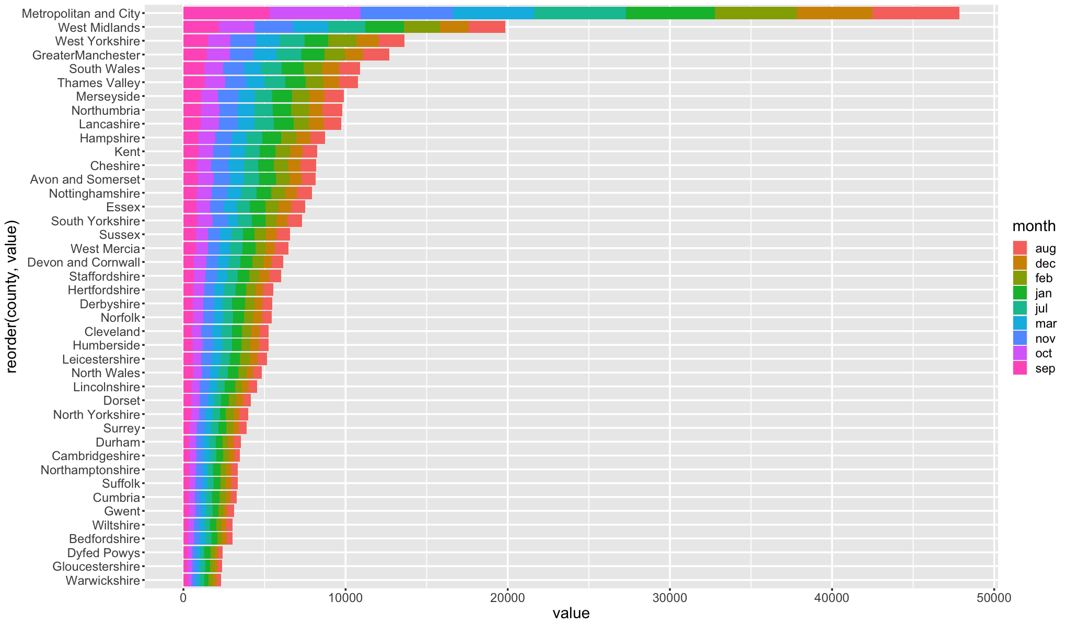

#### 5.3.5.2. Unsuccessful Crimes

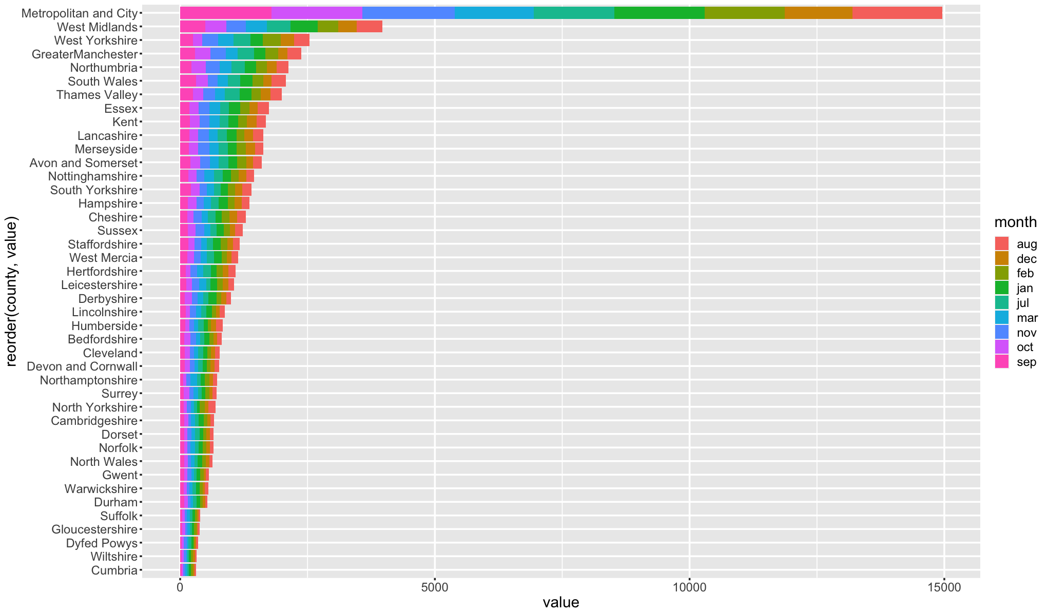

### 5.3.6. Code

#### 5.3.6.1. group_by_year_month

| group_by_year_month <- function(dataframe, year){  dataframe <- dataframe[dataframe$year == year,]  dataframe <- dataframe[dataframe$county != "National",]   dataframe <- dplyr::select(dataframe, -c("year", "yearmon", "region"))  dataframe$sum_of_all <- rowSums(dataframe[, sapply(dataframe, is.numeric)])    dataframe <- dplyr::select(dataframe, c("county", "month", "sum_of_all"))  dataframe <- group_by(dataframe, county, month)  summarise_all(dataframe, funs(sum)) } |
| --- |

#### 5.3.6.2. plot_graph

| plot_graph <- function(in_df, year){  df <- melt(group_by_year_month(in_df, year) , id.vars = c('county', 'month'), variable.name = 'crimes')  options(repr.plot.width = 17, repr.plot.height =10)  ggplot(df, aes(x = value, y = reorder(county, value))) +   geom_bar(aes(fill = month), stat = "identity", position = "stack", width = 0.9) +   theme(text = element_text(size = 18), element_line(linewidth =1)) } |
| --- |

## 5.4. Analysis between Crime Types

### 5.4.1. Correlation

#### 5.4.1.1. Crimes

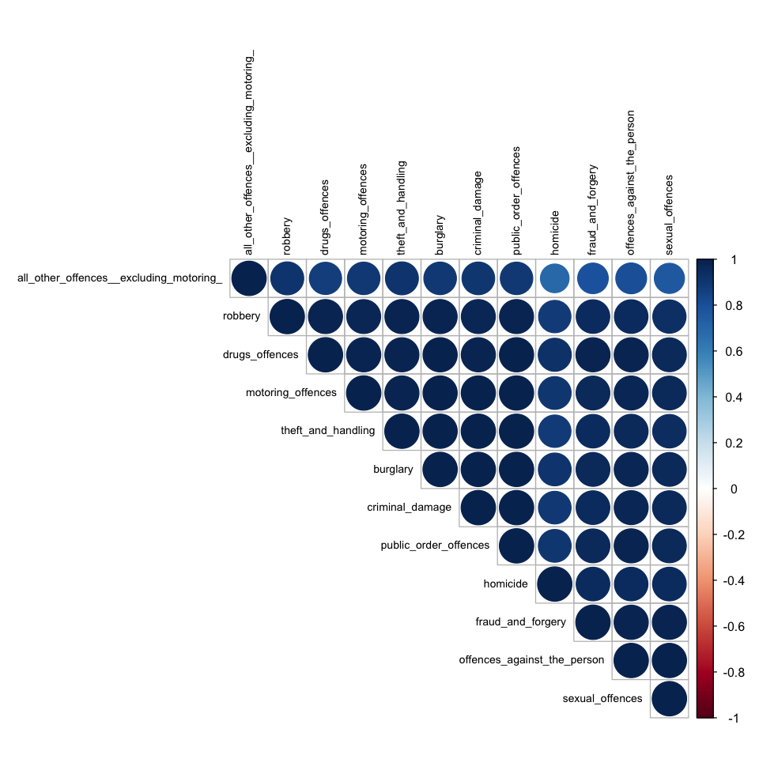

#### 5.4.1.2. Unsuccessful Crimes

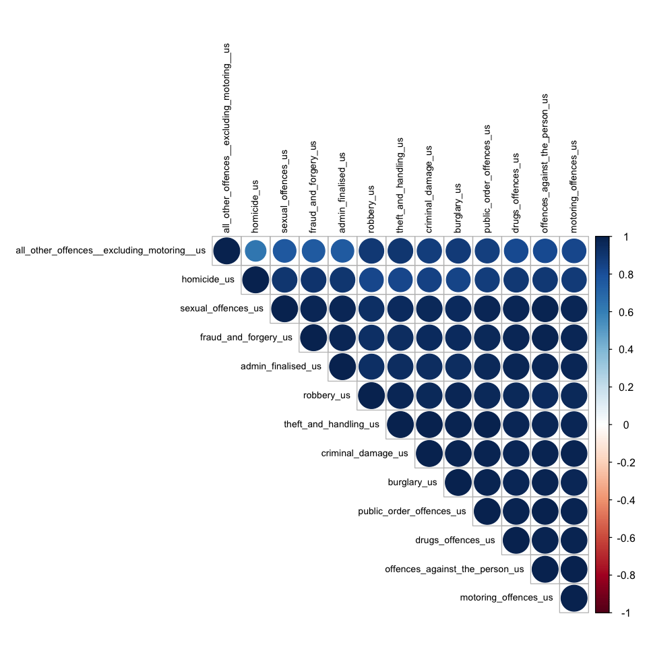

#### 5.4.1.3. Code

| corr_matrix_graph <- function(dataframe){  dataframe <- dplyr::select(dataframe, -c("year", "yearmon", "region"))  num_cols <- sapply(dataframe, is.numeric)  corr_matrix <- cor(dataframe[,num_cols])  options(repr.plot.width = 8, repr.plot.height =8)  corrplot(corr_matrix, type = "upper", order = "hclust", tl.cex = 0.7, tl.col = "black", is.corr = TRUE, mar = c(0, 0, 0, 0))   return(corr_matrix) } |
| --- |

### 5.4.2. Covariance

#### 5.4.2.1. Crimes

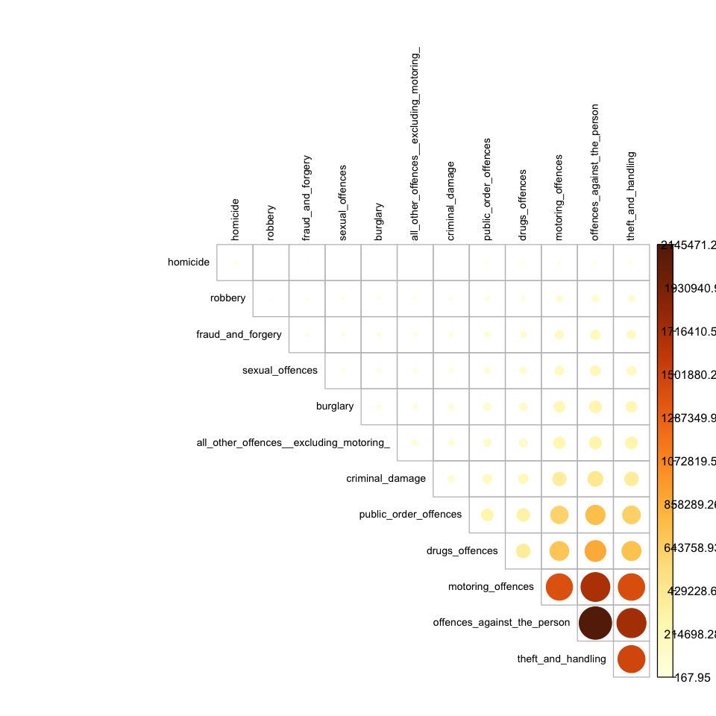

#### 5.4.2.2. Unsuccessful Crimes

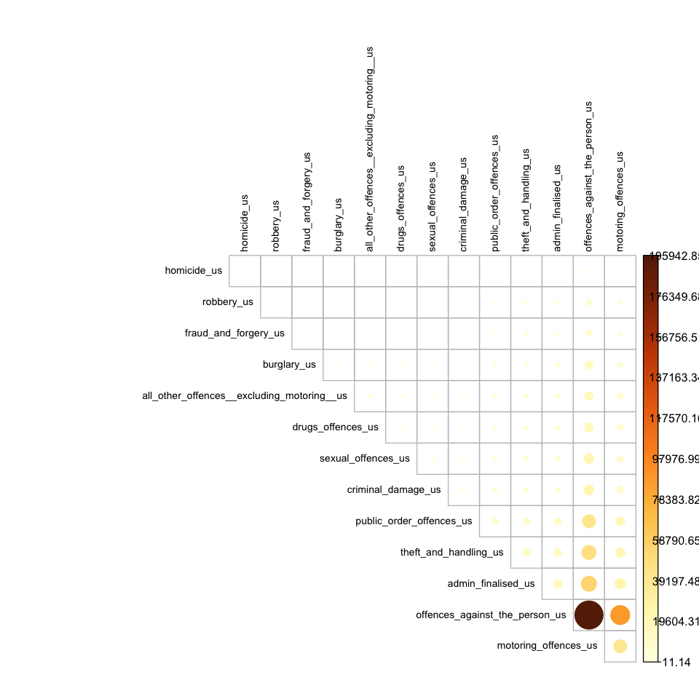

#### 5.4.2.3. Code

| cov_matrix_graph <- function(dataframe){  dataframe <- dplyr::select(dataframe, -c("year", "yearmon", "region"))  num_cols <- sapply(dataframe, is.numeric)  num_cols <- names(num_cols[num_cols])  cov_matrix <- cov(dataframe[,num_cols])  options(repr.plot.width = 8, repr.plot.height =8)  corrplot(cov_matrix, type = "upper", order = "hclust", tl.cex = 0.7, tl.col = "black", is.corr = FALSE, mar = c(0, 0, 0, 0))  return(cov_matrix)  } |
| --- |

## 5.5. Trend Analysis for Successful & Unsuccessful Crimes

### 5.5.1. Visualization

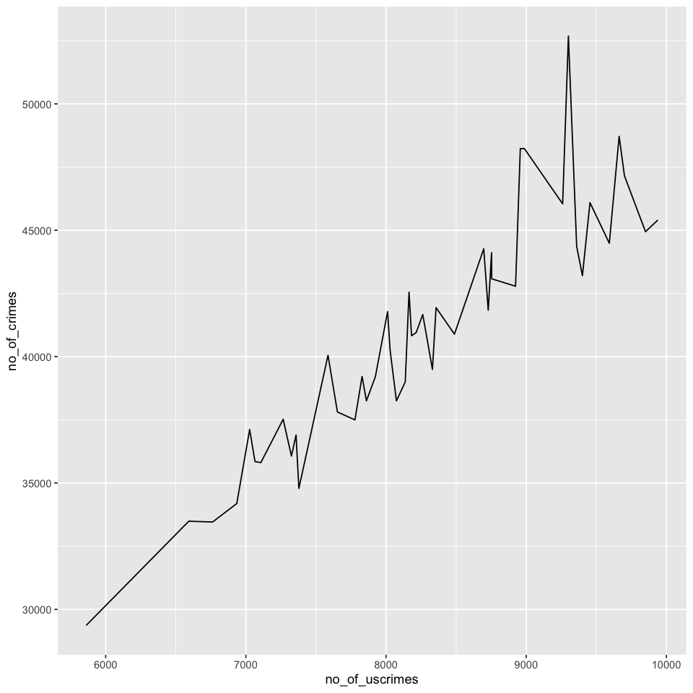

### 5.5.2. Code

| group_and_combine_dfs <- function(crime, uscrime) {  crime <- crime[crime$county == "National", ]  uscrime <- uscrime[uscrime$county == "National", ]   numeric_columns_crime <- dplyr::select(crime, -c("county", "year", "month" ,"yearmon", "region"))  crime$no_of_crimes <- rowSums(numeric_columns_crime)    numeric_columns_uscrime <- dplyr::select(uscrime, -c("county", "year", "month" ,"yearmon", "region"))  uscrime$no_of_uscrimes <- rowSums(numeric_columns_uscrime)    crime <- dplyr::select(crime, c("yearmon", "no_of_crimes"))  uscrime <- dplyr::select(uscrime, c("yearmon", "no_of_uscrimes"))    merged_df <- merge(crime, uscrime, by.x = "yearmon", by.y = "yearmon")    return(merged_df) } |
| --- |

# 6. Predictive Analytics

## 6.1. Regression

### 6.1.1. Linear Regression

#### Dataset Summary

##### Train

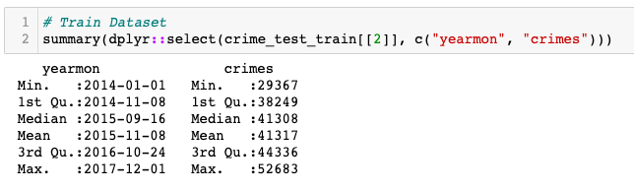

##### Test

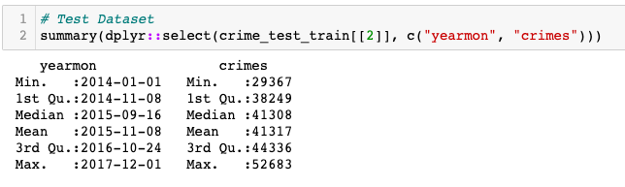

#### Model Summary

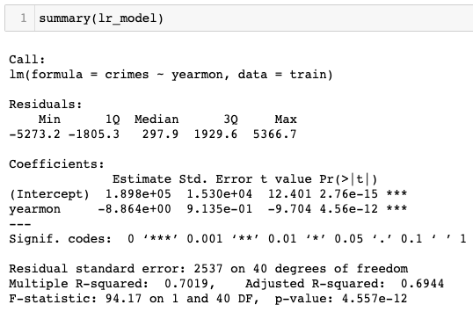

#### Accuracy Matrix

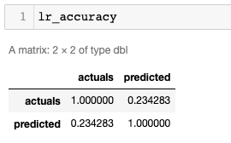

#### Predicted vs Actual Plot

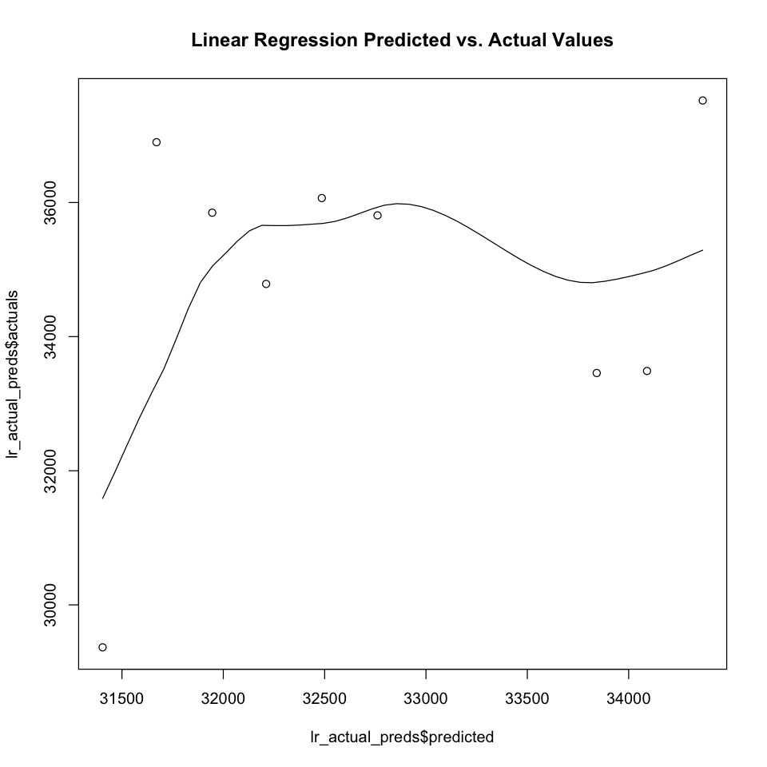

#### Evaluating Stats

| MAE | 2723.76659024003 |
| --- | --- |
| MSE | 9546383.52268908 |
| RMSE | 3089.72224037843 |

#### Code

##### Split Data

| lr_split_data <- function(dataframe){  dataframe <- dataframe[dataframe$county == "National", ]  dataframe$yearmon <- as.Date(dataframe$yearmon)    numeric_columns_df <- dplyr::select(dataframe, -c("county", "year", "month" ,"yearmon", "region"))  dataframe$crimes <- rowSums(numeric_columns_df)    test <- dataframe[dataframe$year == 2018,]  train <- dataframe[dataframe$year != 2018,]    test <- dplyr::select(test, -c("county", "year", "month", "region"))  train <- dplyr::select(train, -c("county", "year", "month", "region"))    return(list(test, train)) } |
| --- |

##### Linear Regression

| linear_regression <- function(test, train){  # training the model   model <- lm(crimes ~ yearmon, data = train)    # using the model for predictions on test data  preds <- predict(model, test, type = "response")  actuals_preds <- data.frame(cbind(actuals=test$crimes, predicted=preds))    # calcultaing correaltion   correlation_accuracy <- cor(actuals_preds)   return(list(model, actuals_preds, correlation_accuracy)) } |
| --- |

### 6.1.2. Multiple Regression

#### Dataset Summary

##### Train

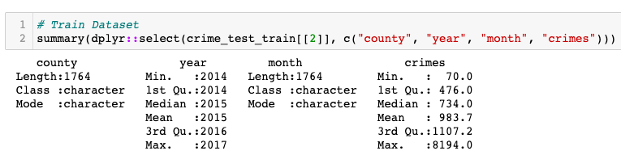

##### Test

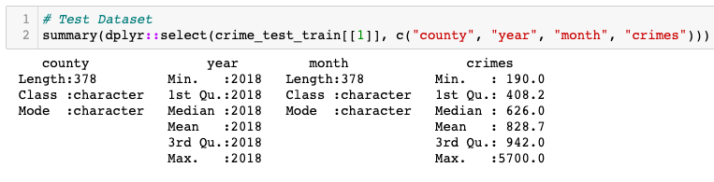

#### Model Summary

| Call: lm(formula = crimes ~ county + year + month, data = train)  Residuals:  Min 1Q Median 3Q Max  -1711.71 -69.02 1.28 63.95 1372.47   Coefficients:  Estimate Std. Error t value Pr(>|t|)  (Intercept) 147114.215 7180.806 20.487 < 2e-16 *** countyBedfordshire -750.762 35.636 -21.067 < 2e-16 *** countyCambridgeshire -671.738 35.636 -18.850 < 2e-16 *** countyCheshire -222.429 35.636 -6.242 5.45e-10 *** countyCleveland -408.405 35.636 -11.460 < 2e-16 *** countyCumbria -675.929 35.636 -18.967 < 2e-16 *** countyDerbyshire -426.643 35.636 -11.972 < 2e-16 *** countyDevon and Cornwall -309.738 35.636 -8.692 < 2e-16 *** countyDorset -649.190 35.636 -18.217 < 2e-16 *** countyDurham -636.238 35.636 -17.854 < 2e-16 *** countyDyfed Powys -750.238 35.636 -21.053 < 2e-16 *** countyEssex -95.643 35.636 -2.684 0.00735 **  countyGloucestershire -804.429 35.636 -22.573 < 2e-16 *** countyGreaterManchester 989.405 35.636 27.764 < 2e-16 *** countyGwent -674.976 35.636 -18.941 < 2e-16 *** countyHampshire 15.190 35.636 0.426 0.66997  countyHertfordshire -410.143 35.636 -11.509 < 2e-16 *** countyHumberside -340.167 35.636 -9.545 < 2e-16 *** countyKent -63.619 35.636 -1.785 0.07440 .  countyLancashire 185.262 35.636 5.199 2.25e-07 *** countyLeicestershire -507.952 35.636 -14.254 < 2e-16 *** countyLincolnshire -590.167 35.636 -16.561 < 2e-16 *** countyMerseyside 195.214 35.636 5.478 4.94e-08 *** countyMetropolitan and City 5517.643 35.636 154.831 < 2e-16 *** countyNorfolk -435.810 35.636 -12.229 < 2e-16 *** countyNorth Wales -502.500 35.636 -14.101 < 2e-16 *** countyNorth Yorkshire -562.238 35.636 -15.777 < 2e-16 *** countyNorthamptonshire -663.667 35.636 -18.623 < 2e-16 *** countyNorthumbria 299.167 35.636 8.395 < 2e-16 *** countyNottinghamshire -145.500 35.636 -4.083 4.65e-05 *** countySouth Wales 458.738 35.636 12.873 < 2e-16 *** countySouth Yorkshire -69.571 35.636 -1.952 0.05107 .  countyStaffordshire -305.381 35.636 -8.569 < 2e-16 *** countySuffolk -653.024 35.636 -18.325 < 2e-16 *** countySurrey -601.952 35.636 -16.891 < 2e-16 *** countySussex -181.690 35.636 -5.098 3.80e-07 *** countyThames Valley 254.071 35.636 7.130 1.48e-12 *** countyWarwickshire -797.548 35.636 -22.380 < 2e-16 *** countyWest Mercia -318.119 35.636 -8.927 < 2e-16 *** countyWest Midlands 1238.429 35.636 34.752 < 2e-16 *** countyWest Yorkshire 576.524 35.636 16.178 < 2e-16 *** countyWiltshire -733.238 35.636 -20.575 < 2e-16 *** year -72.451 3.564 -20.331 < 2e-16 *** monthaug -44.159 19.328 -2.285 0.02245 *  monthdec -119.737 19.328 -6.195 7.29e-10 *** monthfeb 42.190 20.609 2.047 0.04079 *  monthjan 105.727 19.328 5.470 5.16e-08 *** monthjul 36.067 19.328 1.866 0.06221 .  monthjun 29.579 20.575 1.438 0.15071  monthmar 102.746 20.609 4.985 6.81e-07 *** monthmay -19.222 20.575 -0.934 0.35030  monthnov -16.842 20.711 -0.813 0.41622  monthoct 11.287 19.328 0.584 0.55932  monthsep 13.364 19.328 0.691 0.48938  --- Signif. codes: 0 '***' 0.001 '**' 0.01 '*' 0.05 '.' 0.1 ' ' 1  Residual standard error: 163.3 on 1710 degrees of freedom Multiple R-squared: 0.975, Adjusted R-squared: 0.9742  F-statistic: 1256 on 53 and 1710 DF, p-value: < 2.2e-16 |
| --- |

#### Model Accuracy

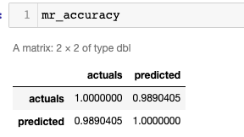

#### Actual vs Predicted Plot

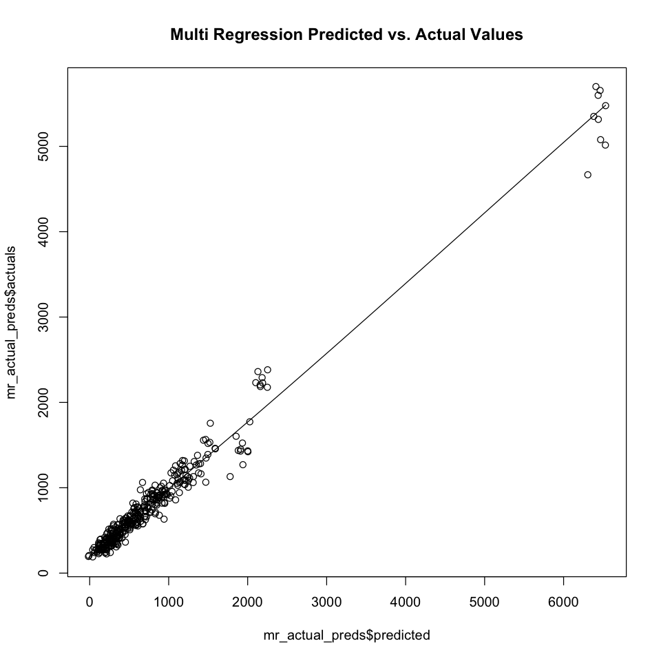

#### Evaluating Stats

| MAE | 146.094951776508 |
| --- | --- |
| MSE | 55675.067652928 |
| RMSE | 235.955647639398 |

#### Code

##### Split Data

| split_data <- function(dataframe){  dataframe <- dataframe[dataframe$county != "National", ]    numeric_columns_df <- dplyr::select(dataframe, -c("county", "year", "month" ,"yearmon", "region"))  dataframe$crimes <- rowSums(numeric_columns_df)   test <- dataframe[dataframe$year == 2018,]  train <- dataframe[dataframe$year != 2018,]   return(list(test, train)) } |
| --- |

##### Multiple Regression

| multiple_regression <- function(test, train){  # training the model   model <- lm(crimes ~ county + year + month, data = train)    # using the model for predictions on test data  preds <- predict(model, test, type = "response")  actuals_preds <- data.frame(cbind(actuals=test$crimes, predicted=preds))    # calcultaing correaltion   correlation_accuracy <- cor(actuals_preds)    return(list(model, actuals_preds, correlation_accuracy)) } |
| --- |

## 6.2. Clustering

### 6.2.1. KMeans

#### Dataset Summary

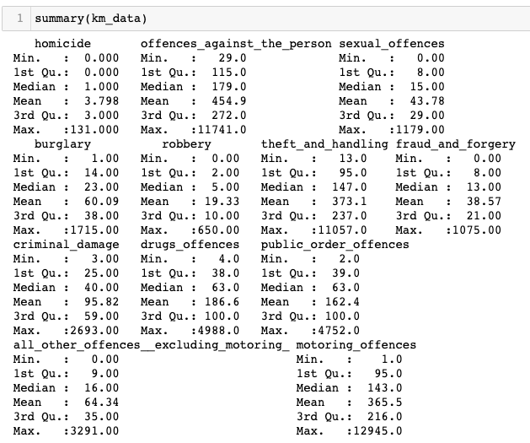

#### With 4 Clusters

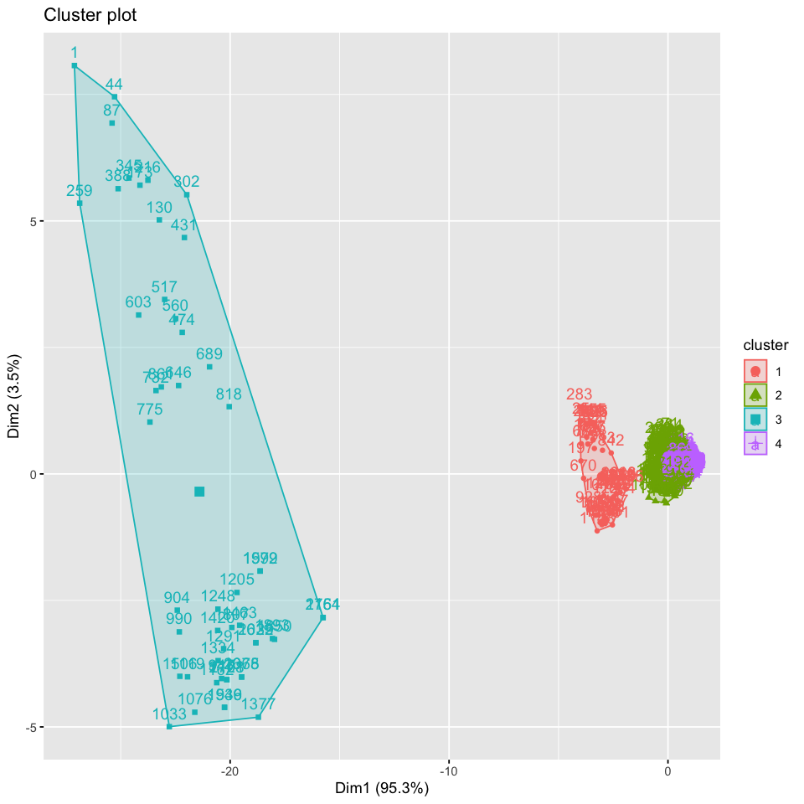

#### With 5 Clusters

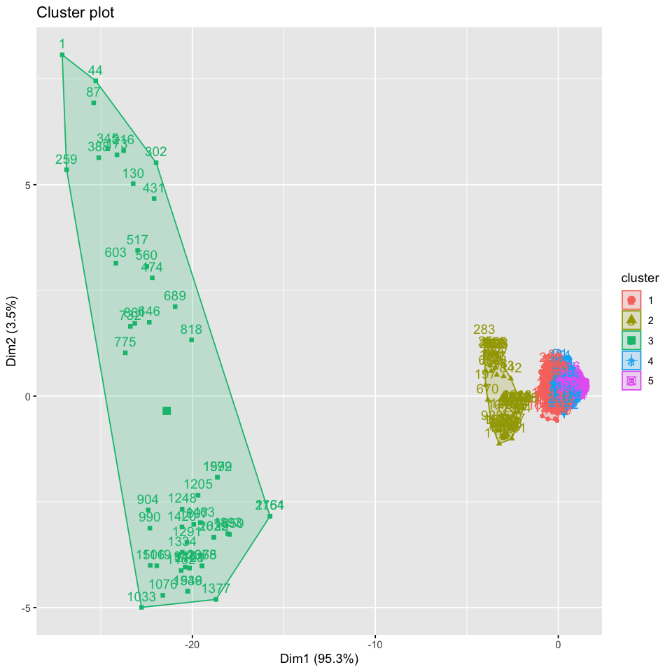

#### With 6 Clusters

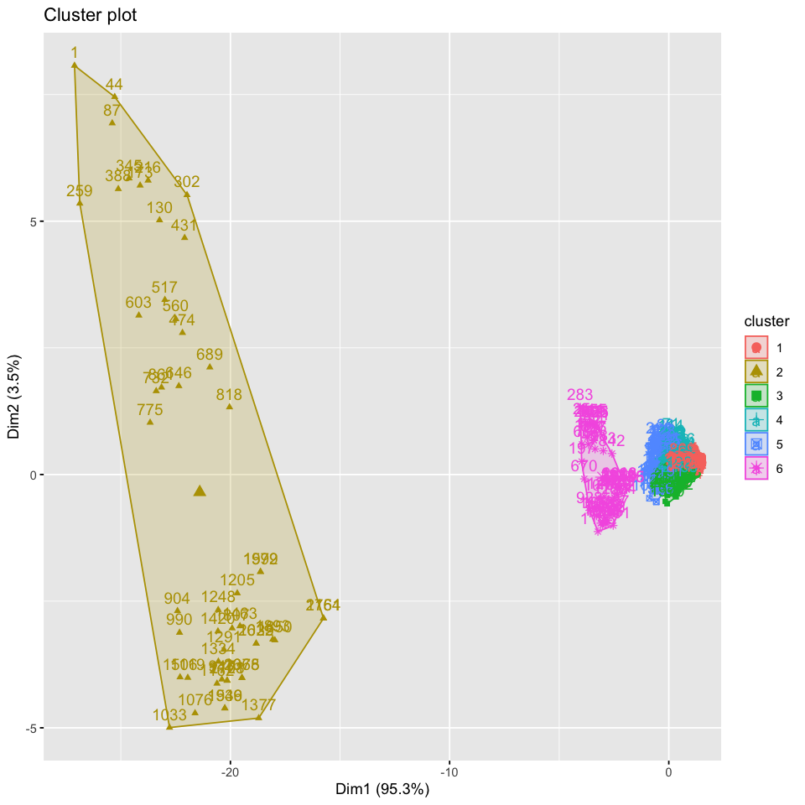

#### Summary

Text Here

#### Code

##### Remove Non Numeric Columns

| remove_non_numeric_cols <- function(dataframe) {  dataframe <- dplyr::select(dataframe, -c("county", "year", "month" ,"yearmon", "region"))  return(dataframe) } |
| --- |

##### K Means Clustering

| kmeans_clustering <- function(dataframe, clusters){  dataframe <- scale(dataframe)  model <- kmeans(dataframe, centers = clusters, nstart = 25)  return(model) } |
| --- |

### 6.2.2. Hierarchical Clustering

#### Data Summary

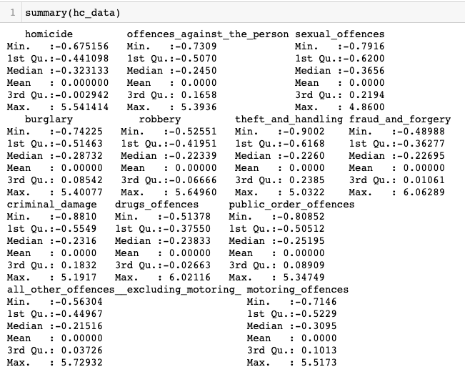

#### Cluster Dendrogram

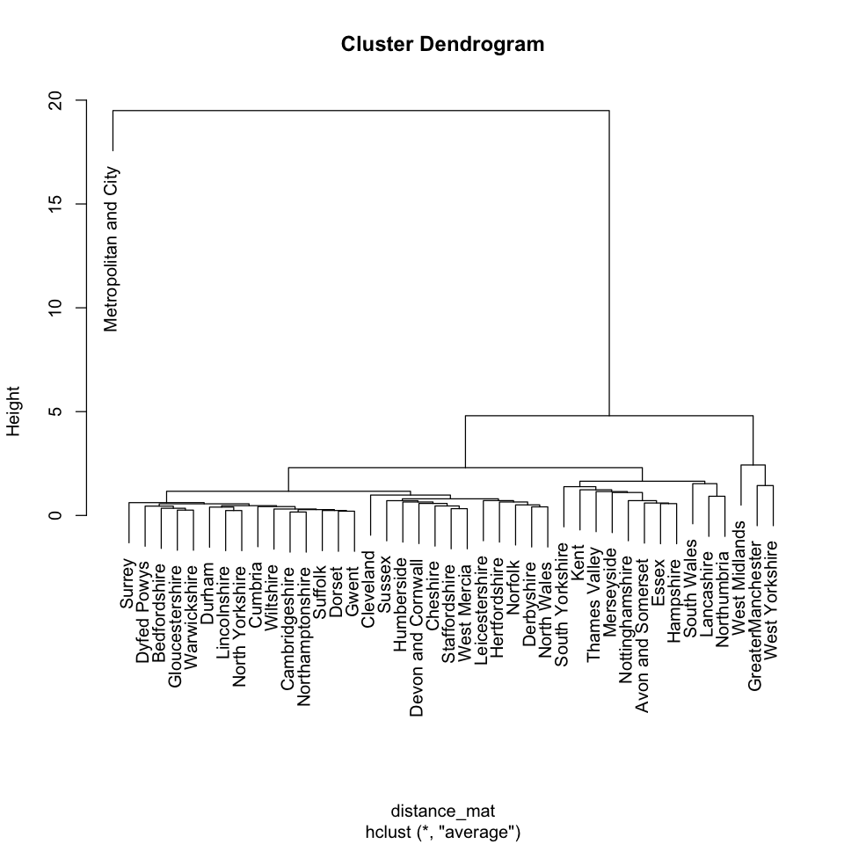

#### Dendrogram with 2 Clusters

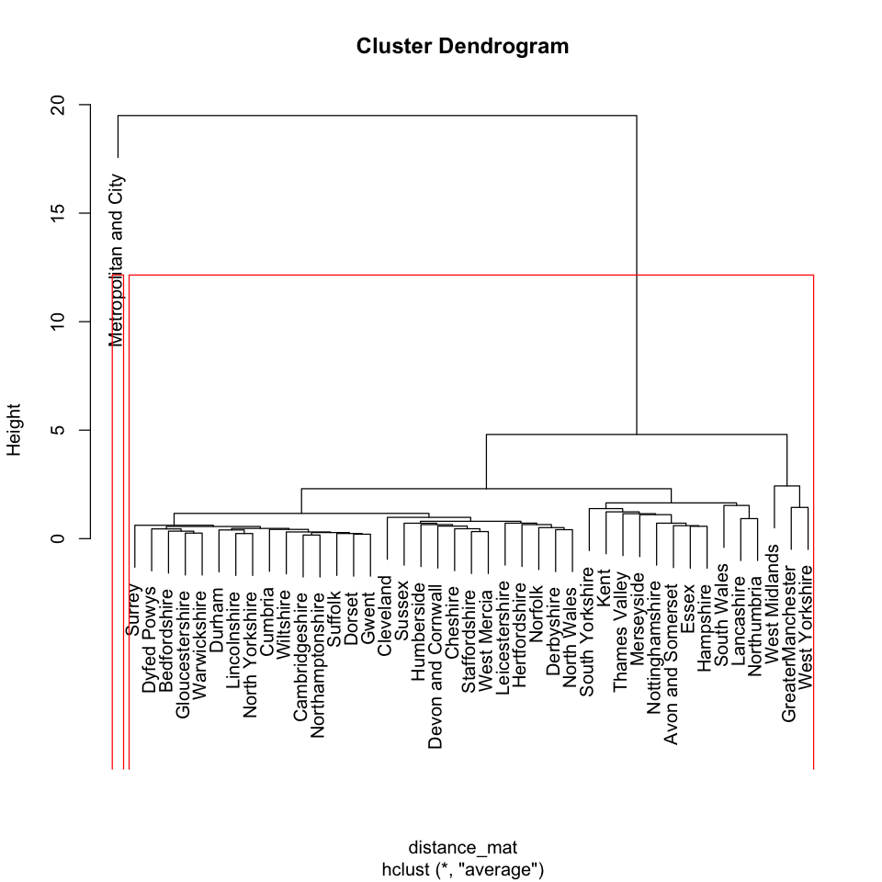

#### Dendrogram with 3 Clusters

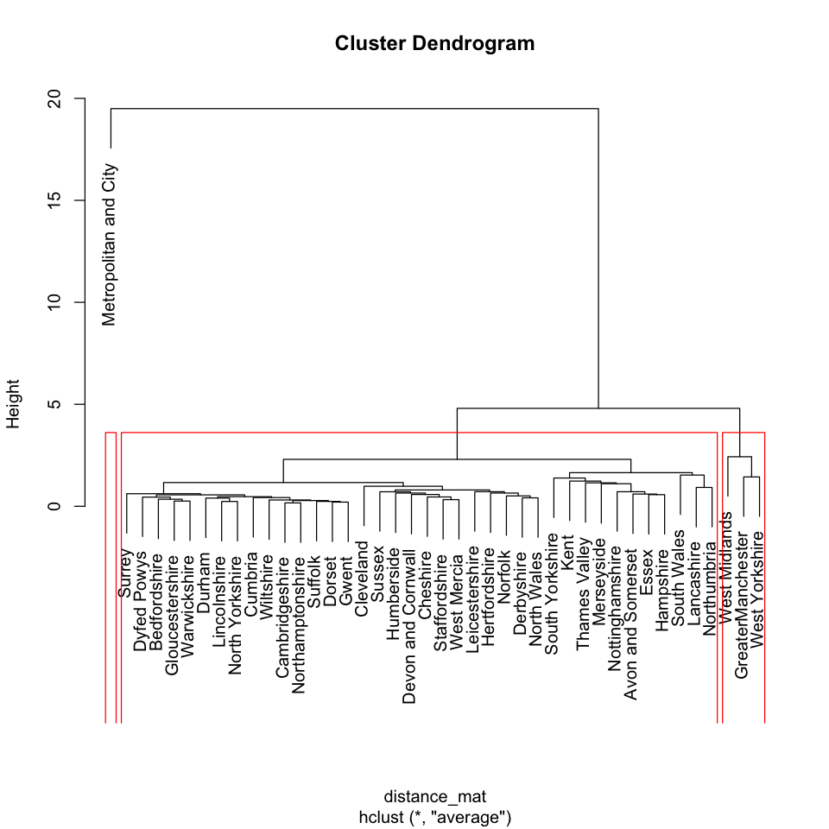

#### Dendrogram with 5 Clusters

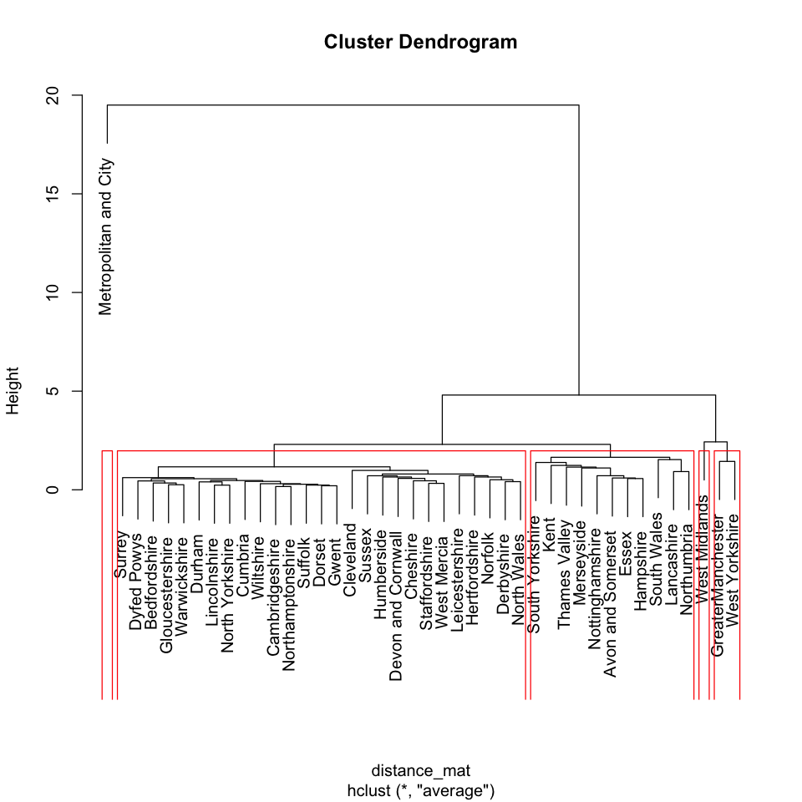

#### Dendrogram with 8 Clusters

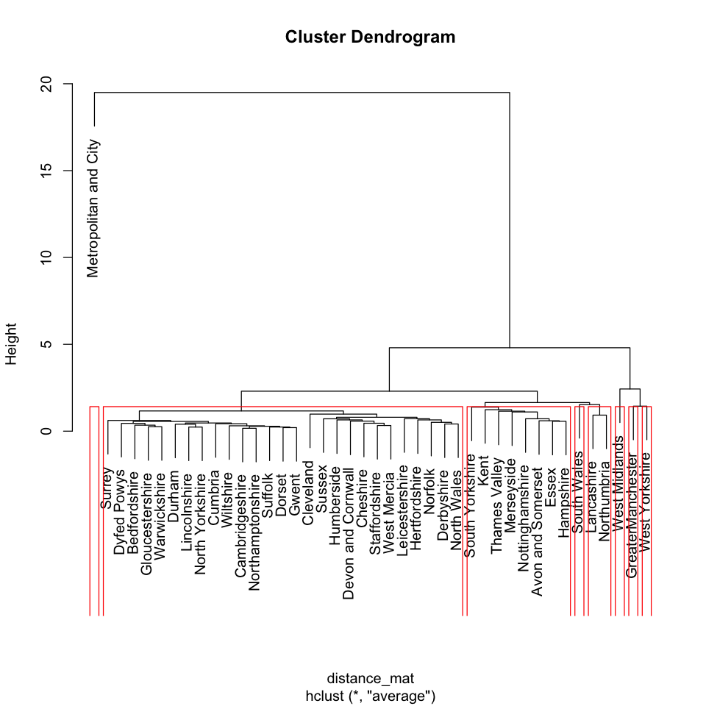

#### Dendrogram with 11 Clusters

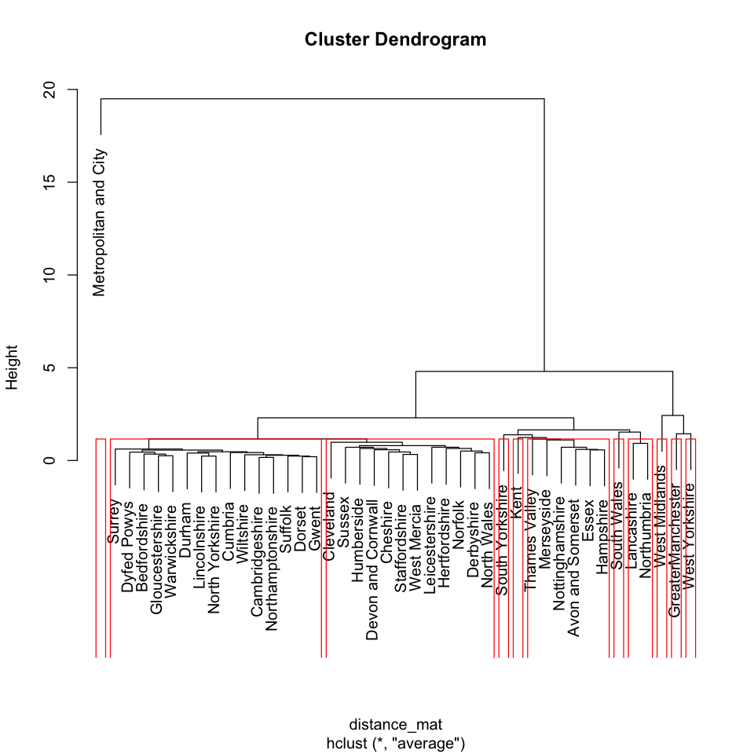

##### Code

##### Group By Country

| group_by_county <- function(dataframe){  dataframe <- dplyr::select(dataframe, -c("year", "month" ,"yearmon", "region"))  dataframe <- dataframe[dataframe$county != "National",]  dataframe <- group_by(dataframe, county)  dataframe <- summarise_all(dataframe, funs(sum))  dataframe2 <- dataframe[,-1]  rownames(dataframe2) <- dataframe$county  dataframe2 <- scale(dataframe2)  return(dataframe2) } |
| --- |

##### HC Clustering

| hc_clustering <- function(dataframe) {  distance_mat <- dist(dataframe, method = 'euclidean')  set.seed(240)  model <- hclust(distance_mat, method = "average")  return(list(distance_mat, model)) } |
| --- |

## 6.3. Classification

### 6.3.1. SVM

#### Dataset Summary

##### Train

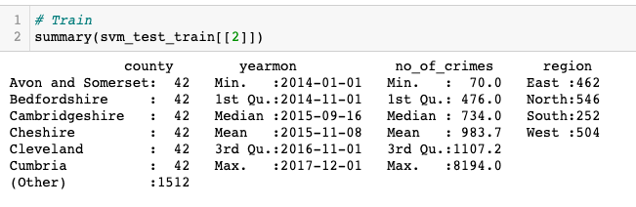

##### Test

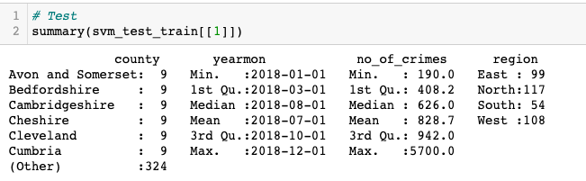

#### Model Summary

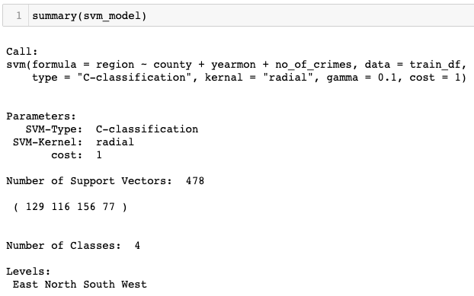

#### Classification Report

| Confusion Matrix and Statistics   Reference Prediction East North South West  East 99 0 0 0  North 0 117 0 0  South 0 0 54 0  West 0 0 0 108  Overall Statistics    Accuracy : 1   95% CI : (0.9903, 1)  No Information Rate : 0.3095   P-Value [Acc > NIR] : < 2.2e-16     Kappa : 1     Mcnemar's Test P-Value : NA   Statistics by Class:   Class: East Class: North Class: South Class: West Sensitivity 1.0000 1.0000 1.0000 1.0000 Specificity 1.0000 1.0000 1.0000 1.0000 Pos Pred Value 1.0000 1.0000 1.0000 1.0000 Neg Pred Value 1.0000 1.0000 1.0000 1.0000 Prevalence 0.2619 0.3095 0.1429 0.2857 Detection Rate 0.2619 0.3095 0.1429 0.2857 Detection Prevalence 0.2619 0.3095 0.1429 0.2857 Balanced Accuracy 1.0000 1.0000 1.0000 1.0000 |
| --- |

#### Model Roc

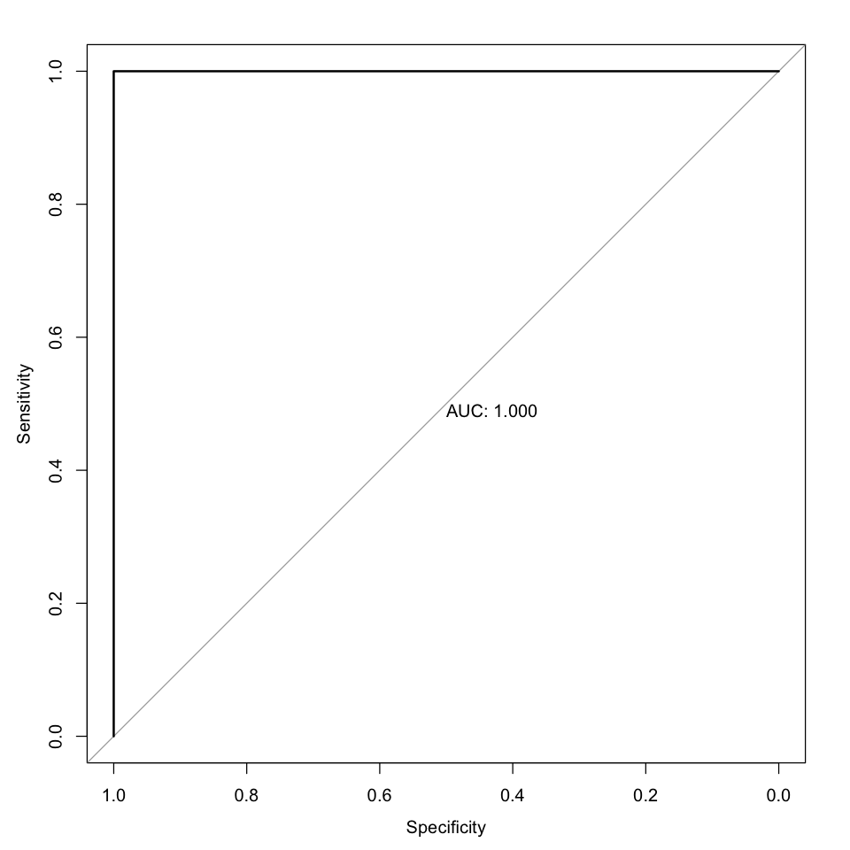

#### Code

##### SVM Model Generate

| svm_model_generate <- function(train_df, test_df) {  set.seed(123)    svm_model <- svm(region ~ county + yearmon + no_of_crimes, data = train_df, type = 'C-classification', kernal = "radial", gamma = 0.1, cost = 1)    test_predictions <- predict(svm_model, test_df)  confusion_matrix <- confusionMatrix(as.factor(test_predictions), as.factor(test_df$region))  model_roc = multiclass.roc(test_df$region ~ as.numeric(as.factor(test_predictions)), plot=TRUE, print.auc = TRUE)   return(list(svm_model, confusion_matrix)) } |
| --- |

### 6.3.2. Random Forest

#### Dataset Summary

##### Train

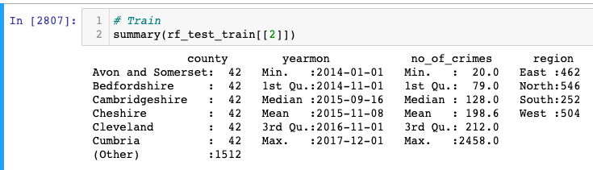

##### Test

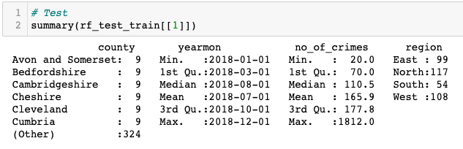

#### Model Summary

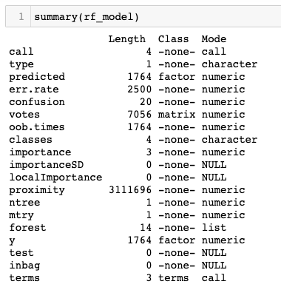

#### Classification Report

| Confusion Matrix and Statistics   Reference Prediction East North South West  East 99 0 0 0  North 0 117 0 0  South 0 0 54 0  West 0 0 0 108  Overall Statistics    Accuracy : 1   95% CI : (0.9903, 1)  No Information Rate : 0.3095   P-Value [Acc > NIR] : < 2.2e-16     Kappa : 1     Mcnemar's Test P-Value : NA   Statistics by Class:   Class: East Class: North Class: South Class: West Sensitivity 1.0000 1.0000 1.0000 1.0000 Specificity 1.0000 1.0000 1.0000 1.0000 Pos Pred Value 1.0000 1.0000 1.0000 1.0000 Neg Pred Value 1.0000 1.0000 1.0000 1.0000 Prevalence 0.2619 0.3095 0.1429 0.2857 Detection Rate 0.2619 0.3095 0.1429 0.2857 Detection Prevalence 0.2619 0.3095 0.1429 0.2857 Balanced Accuracy 1.0000 1.0000 1.0000 1.0000 |
| --- |

#### Model Roc



#### Code

##### Rf Model Generate

| rf_model_generate <- function(train_df, test_df) {  set.seed(123)    rf_model <- randomForest(region ~ county + yearmon + no_of_crimes, data = train_df, proximity=TRUE)    test_predictions <- predict(rf_model, test_df)  confusion_matrix <- confusionMatrix(as.factor(test_predictions), as.factor(test_df$region))  model_roc = multiclass.roc(test_df$region ~ as.numeric(as.factor(test_predictions)), plot=TRUE, print.auc = TRUE)   return(list(rf_model, confusion_matrix)) } |
| --- |

### Summary

### Joint Code

| classify_split_data <- function(dataframe){  dataframe <- dataframe[dataframe$county != "National", ]  dataframe$yearmon <- as.Date(dataframe$yearmon)  dataframe$region <- as.factor(dataframe$region)  dataframe$county <- as.factor(dataframe$county)    numeric_columns_df <- dplyr::select(dataframe, -c("county", "year", "month" ,"yearmon", "region"))  dataframe$no_of_crimes <- rowSums(numeric_columns_df)    test <- dataframe[dataframe$year == 2018,]  train <- dataframe[dataframe$year != 2018,]   test <- dplyr::select(test, c("county", "yearmon" ,"no_of_crimes" ,"region"))  train <- dplyr::select(train, c("county", "yearmon", "no_of_crimes" ,"region"))      return(list(test, train)) } |
| --- |

### 

# 7. Prescriptive Analytics

### 7.1.1. Crime

#### Dataset Summary

##### Data Frame

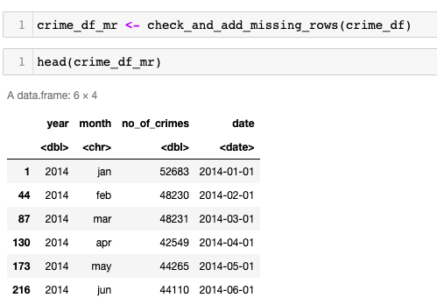

##### Time Series

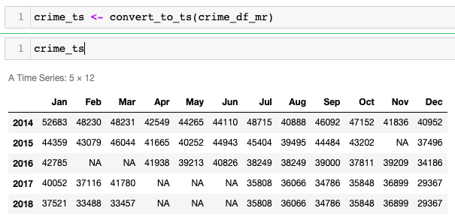

#### Time Series Data Plot

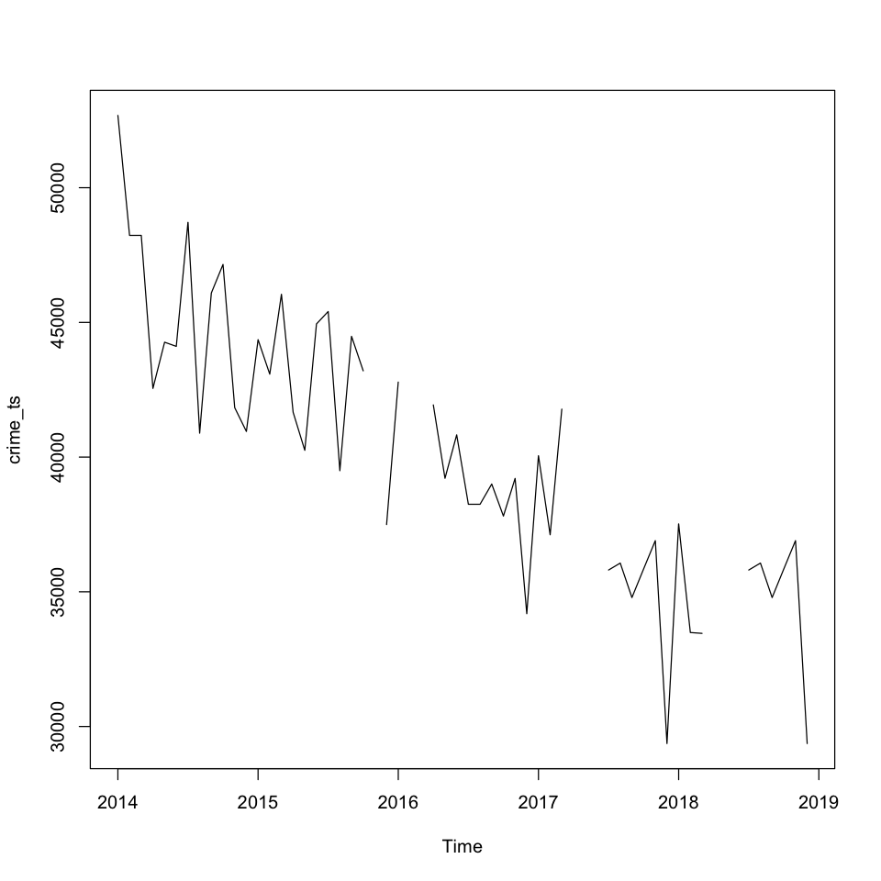

#### Filling Missing Data with Mice

##### Mice Summary

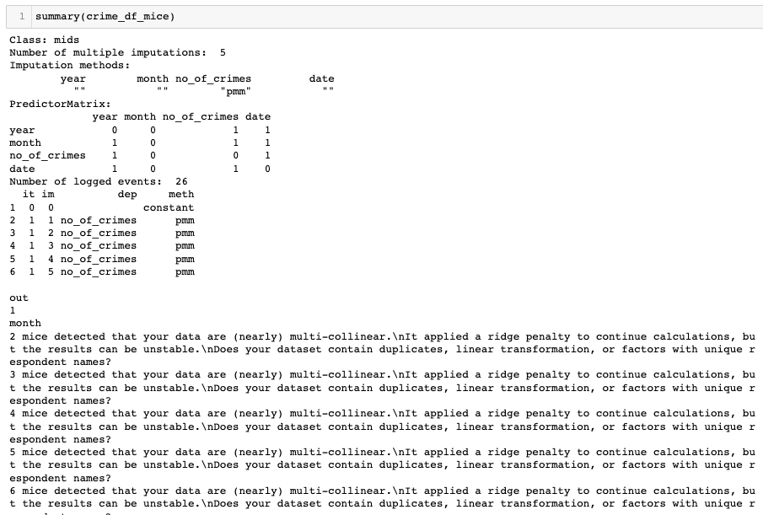

##### Mice Filled Data

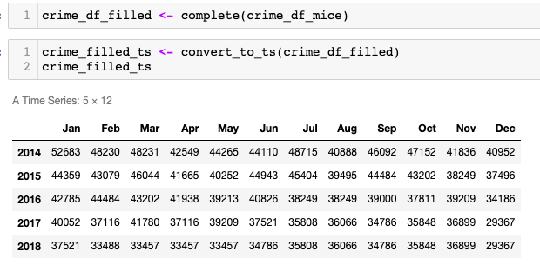

#### Filled Time Series Data Plot

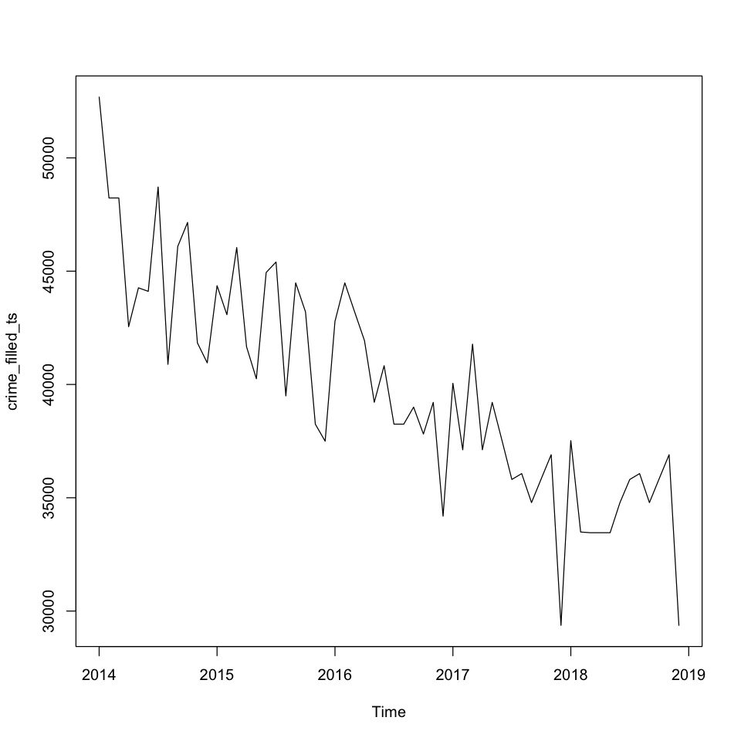

#### Data Patterns Check

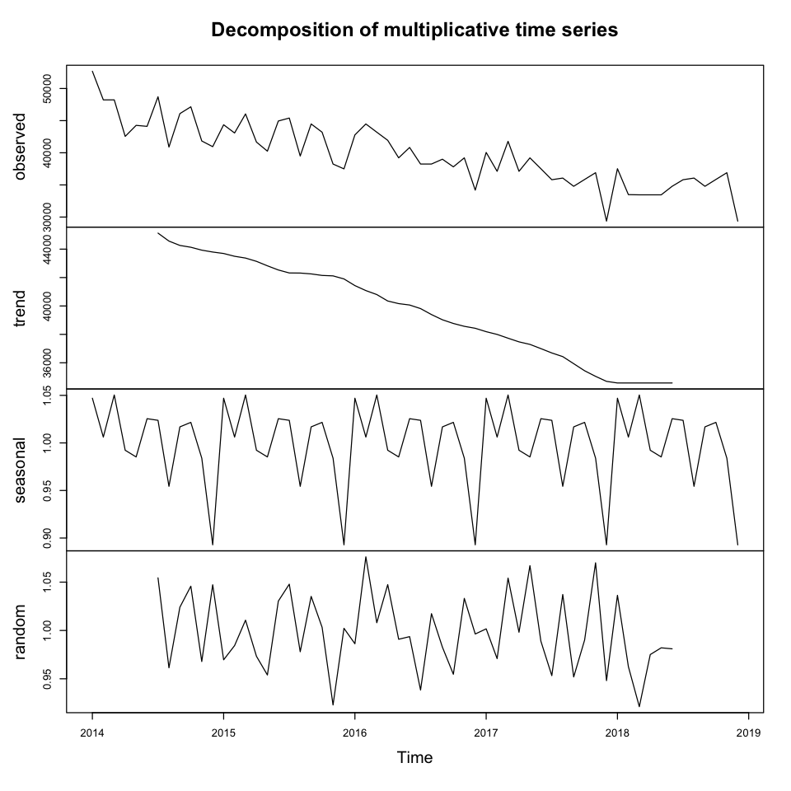

#### Diagnostic Check

##### Residuals

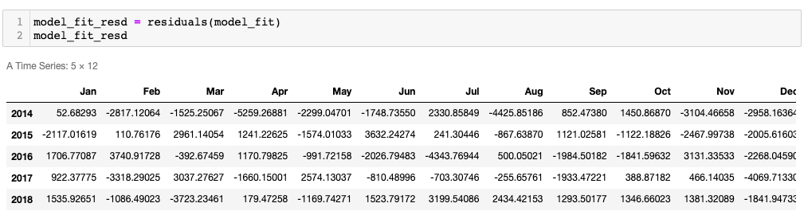

##### Box-Ljung test

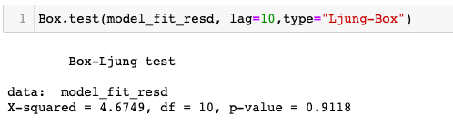

#### Forecasting

##### 4 Years

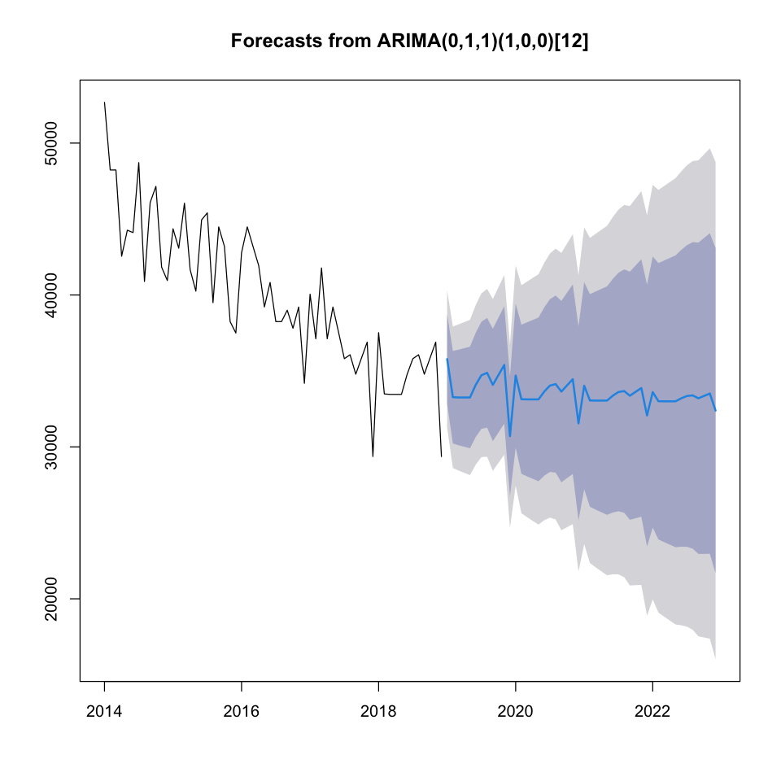

##### 8 Years

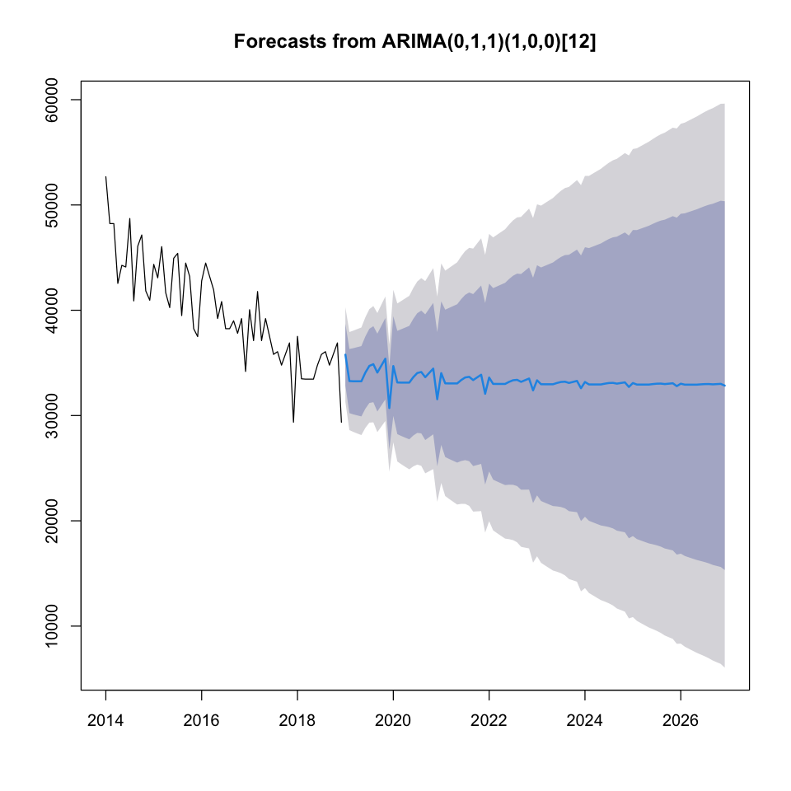

### 7.1.2. Un successful Crimes

#### Dataset Summary

##### Data Frame

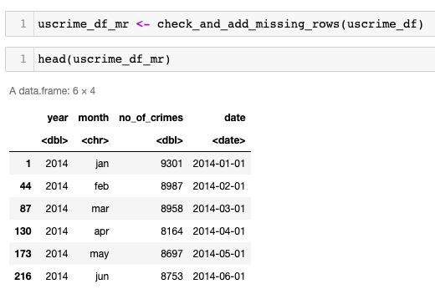

##### Time Series

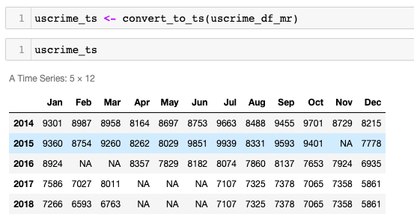

#### Time Series Data Plot

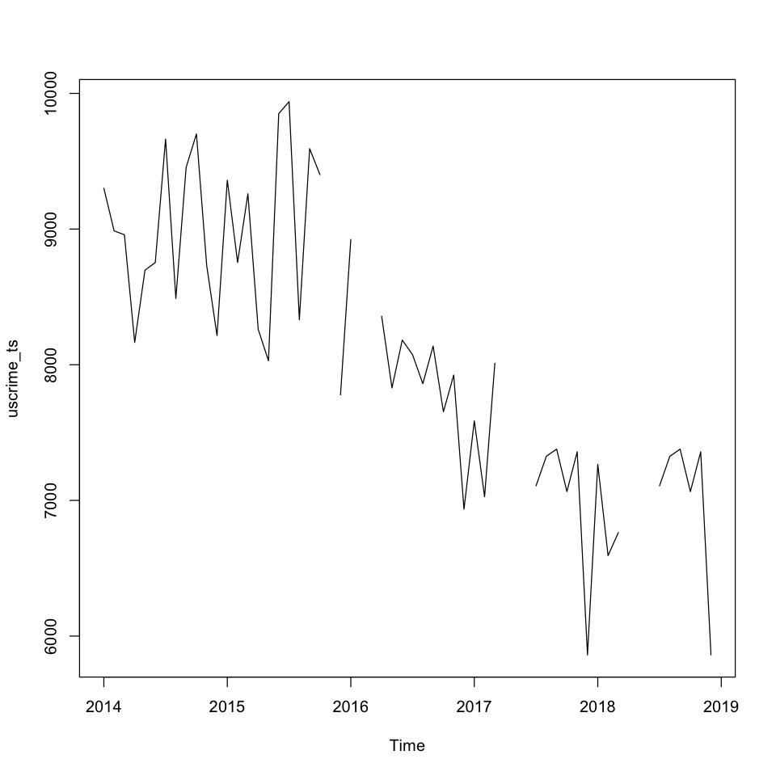

#### Filling Missing Data with Mice

##### Mice Summary

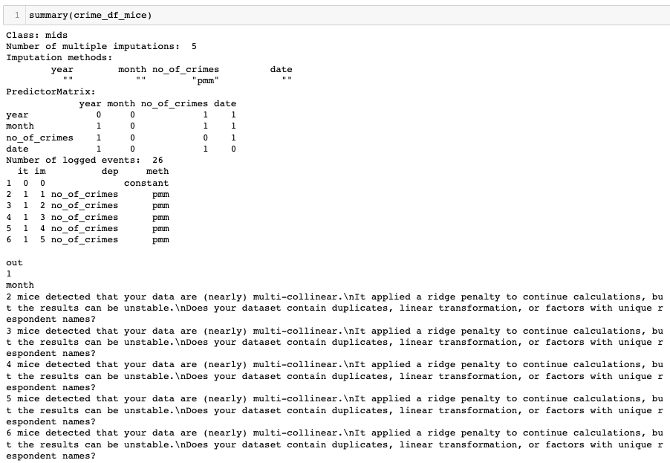

##### Mice Filled Data

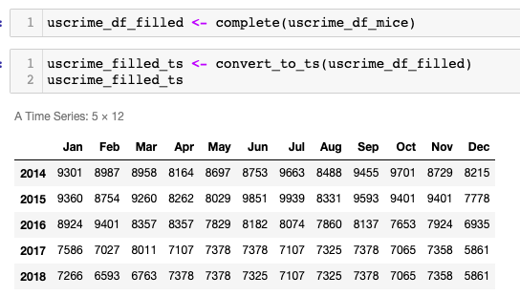

#### Filled Time Series Data Plot

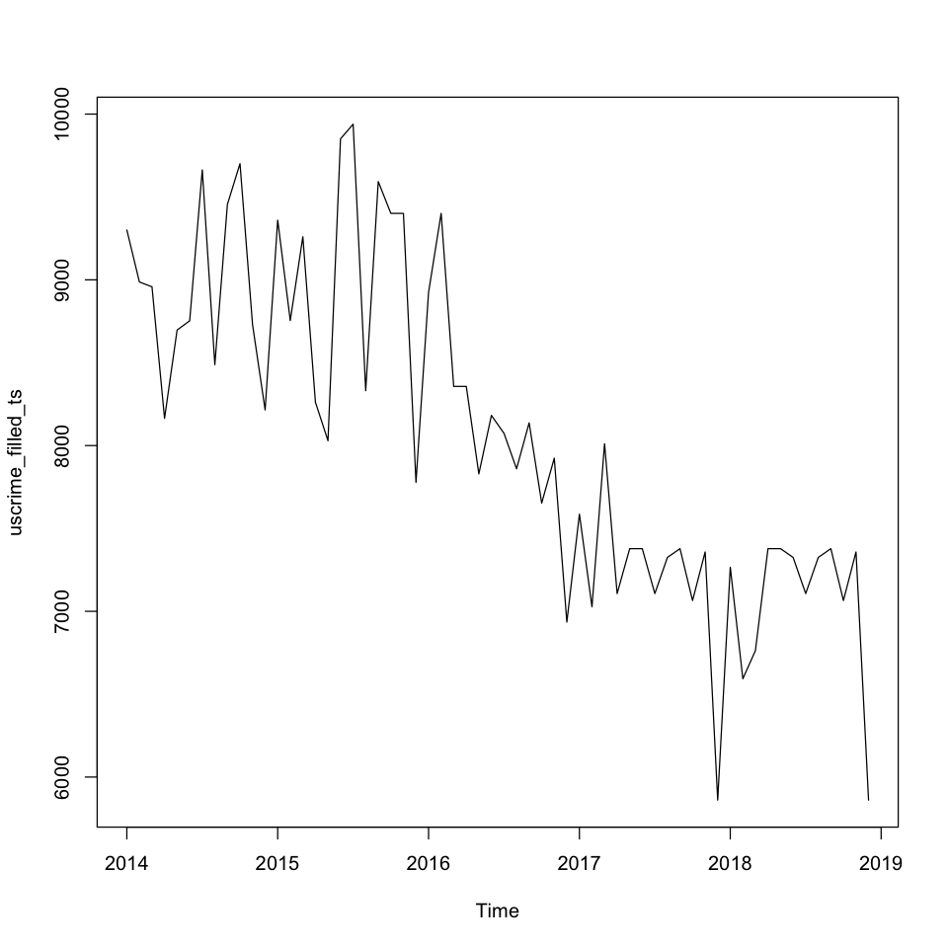

#### Data Patterns Check

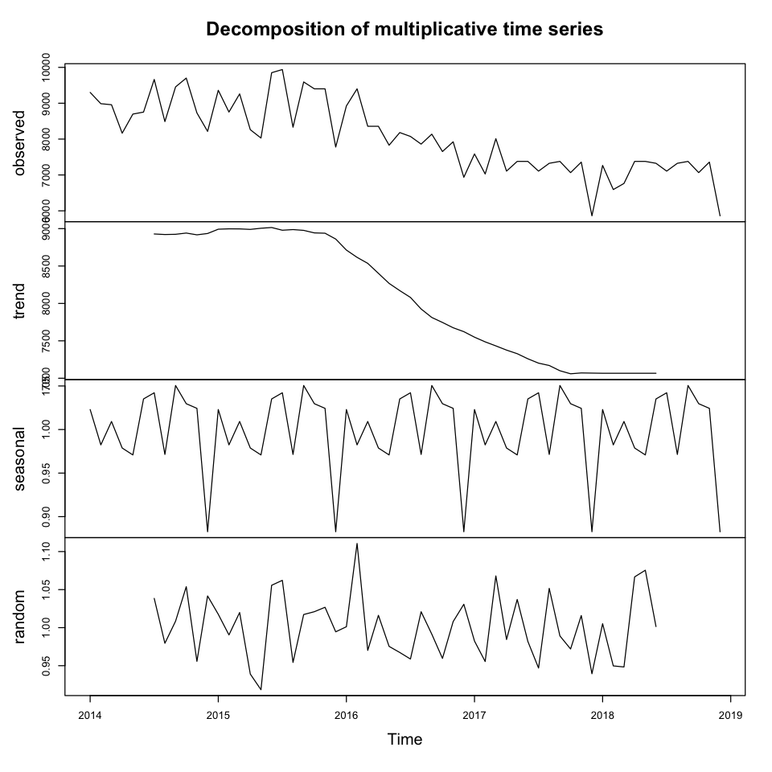

#### Diagnostic Check

##### Residuals

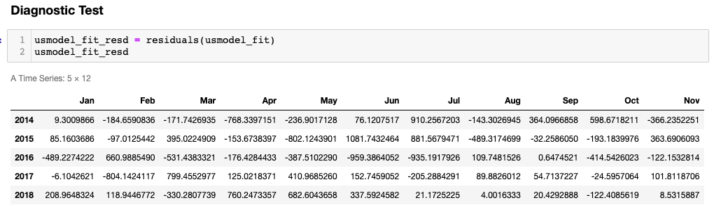

##### Box-Ljung test

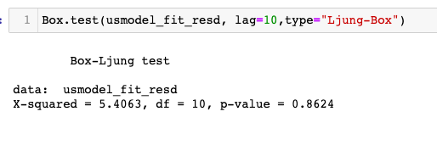

#### Forecasting

##### 4 Years

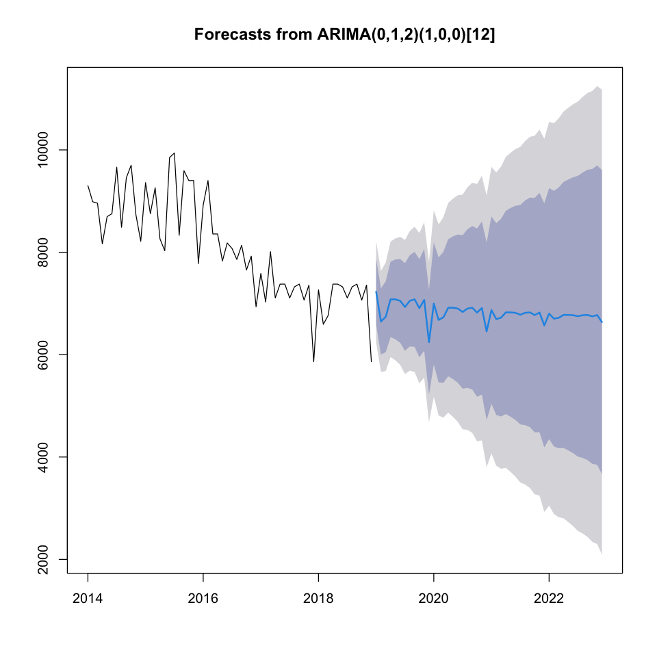

##### 8 Years



### Summary

### Joint Code

##### Check and Add Missing Rows with NA

| check_and_add_missing_rows <- function(dataframe){  dataframe <- dataframe[dataframe$county == "National",]    numeric_columns_df <- dplyr::select(dataframe, -c("county", "year", "month" ,"yearmon", "region"))  dataframe$no_of_crimes <- rowSums(numeric_columns_df)  df <- dplyr::select(dataframe, c("year", "month","no_of_crimes"))   unique_years <- c(2014, 2015, 2016, 2017, 2018)  months <- c("jan", "feb", "mar", "apr", "may", "jun", "jul", "aug", "sep", "oct", "nov", "dec")  for(year in unique_years){  missing_months <- setdiff(months, df$month[df$year == year])  for(missing_month in missing_months){  new_row <- data.frame(year = year, month = missing_month, no_of_crimes = NA)  df <- rbind(df, new_row)  }  }    df$date <- as.Date(paste(df$year, df$month, "01", sep = "-"), "%Y-%b-%d")  df <- df[order(df$date),]    return(df) } |
| --- |

##### Convert to Time Series

| convert_to_ts <- function(df){  months <- c("jan", "feb", "mar", "apr", "may", "jun", "jul", "aug", "sep", "oct", "nov", "dec")  ts_obj <- ts(df$no_of_crimes, start = c(df$year[1], match(df$month[1], months)), frequency = 12)   return(ts_obj) } |
| --- |

### 

# 8. References